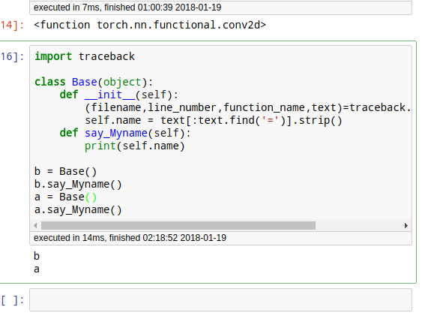

## 在win下共享了

## 教程资源

陈云的教程感觉讲解的最细致

<http://pytorch.apachecn.org/cn/0.3.0/distributed.html> 这个中文文档都出来了!

<https://github.com/SherlockLiao/code-of-learn-deep-learning-with-pytorch>

<https://github.com/SherlockLiao/pytorch-beginner>

<https://github.com/hunkim/PyTorchZeroToAll>

<https://github.com/ritchieng/the-incredible-pytorch>

<https://github.com/spro/practical-pytorch>

<http://pytorch.org/tutorials/index.html>

<https://discuss.pytorch.org/>

<https://github.com/yunjey/pytorch-tutorial>

<http://pytorch.org/docs/0.3.0/>

## 源码

<http://pytorch.org/2017/05/11/Internals.html>

###### THP和TH前缀

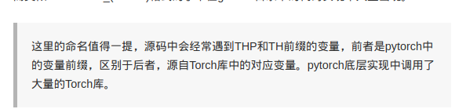

#### torch

###### tensor

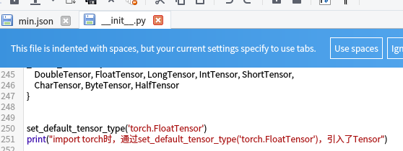

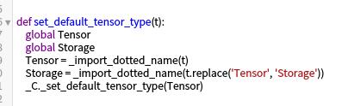



#### _C

使各种数据操作直接暴露在torch下

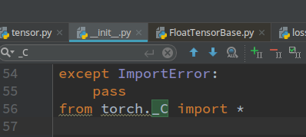

##### torch/csrc/Module.cpp

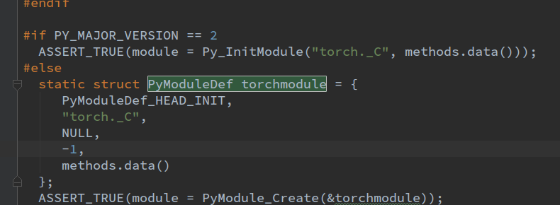

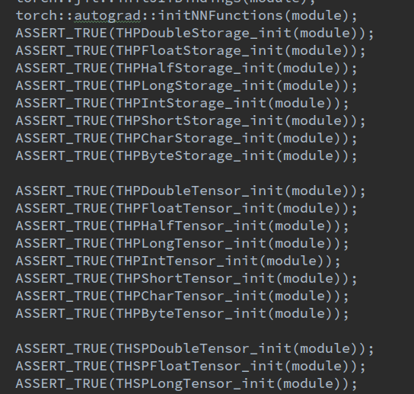

##### setup.py

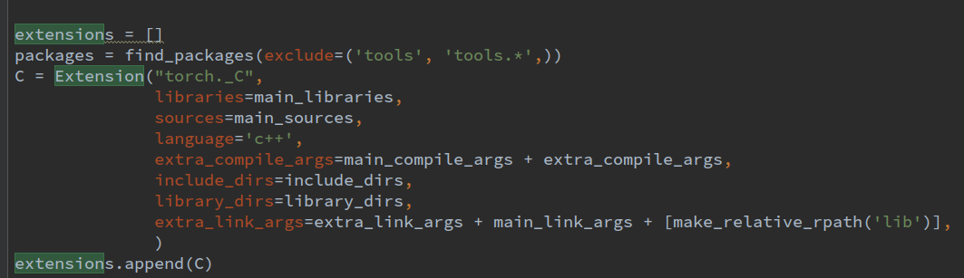

###### 生成代码

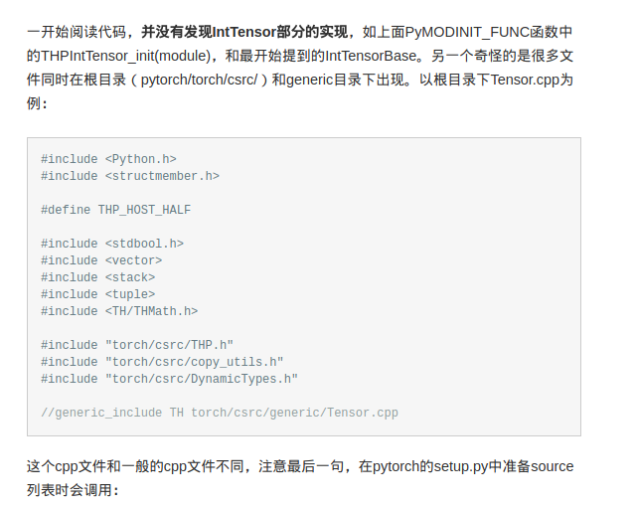

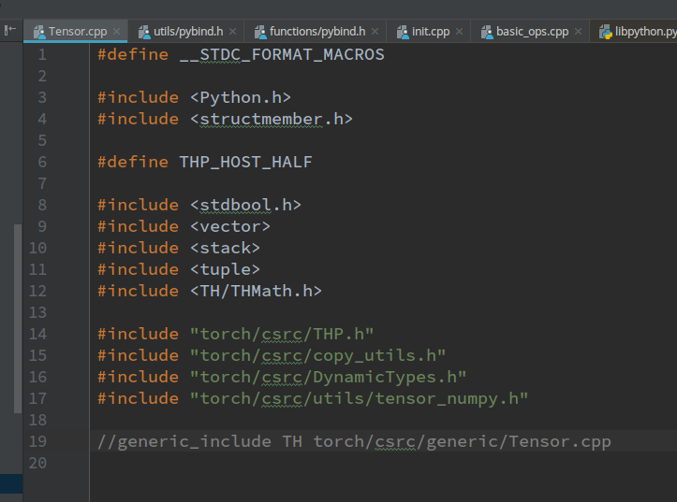

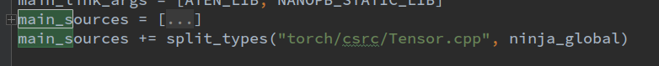



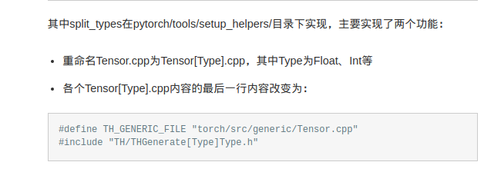

### torchvision模块

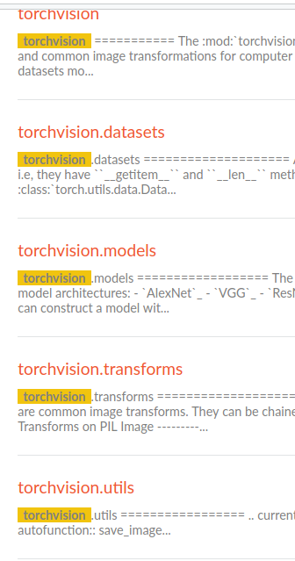

## Pytorch使用实践

### 数据准备

#### 框架自带数据



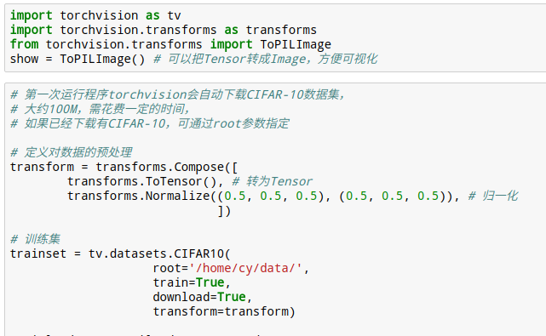

###### 1-花型分类边界

<http://localhost:8891/notebooks/code-of-learn-deep-learning-with-pytorch-master/chapter3_NN/nn-sequential-module.ipynb>

x = torch.from_numpy(x).float()  
y = torch.from_numpy(y).float()  
#看下面 ，还不如直接torch.Tensor()呢

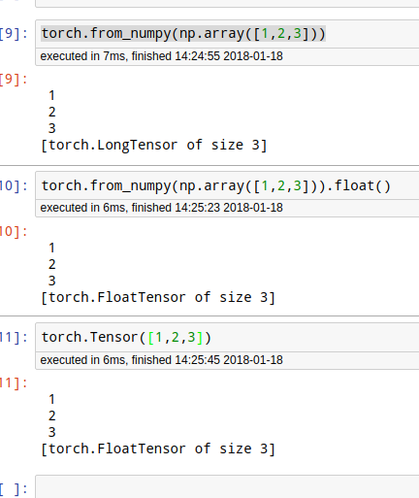

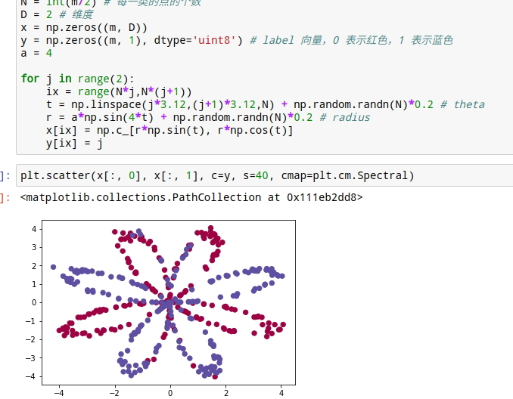

#### 数据准备-数据增强

先看无增强的！

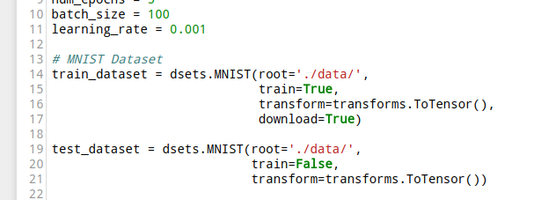

<http://localhost:8888/notebooks/code-of-learn-deep-learning-with-pytorch-master/chapter4_CNN/data-augumentation.ipynb>

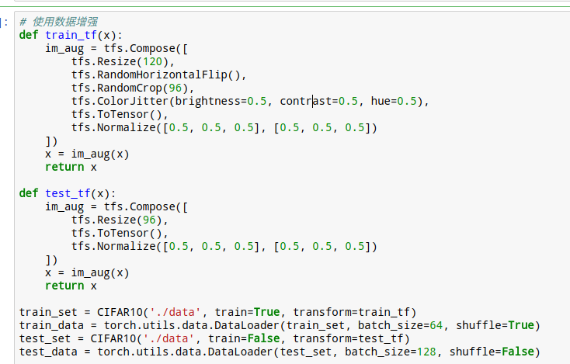

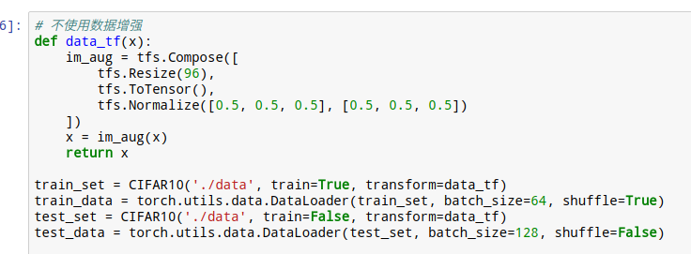

### 自然语言数据

##### 1 - word_to_idx 和idx_to_word

##### 方法1：set + enumerate

##### fig:

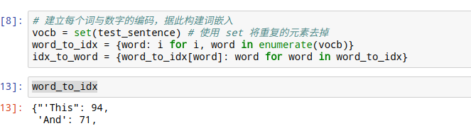

##### 方法2：依次读取+len

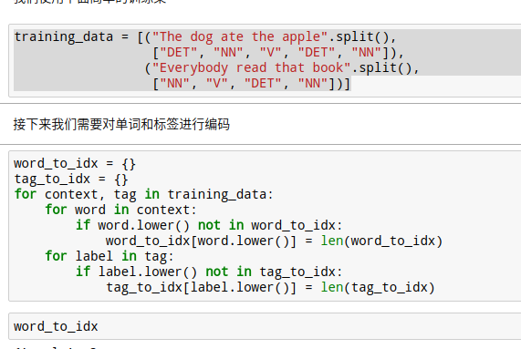

word_to_idx = {}  
tag_to_idx = {}  
for context, tag in training_data:  
 for word in context:  
 if word.lower() not in word_to_idx:  
 word_to_idx[word.lower()] = len(word_to_idx)  
 for label in tag:  
 if label.lower() not in tag_to_idx:  
 tag_to_idx[label.lower()] = len(tag_to_idx)

##### 1-1 字母 char_to_index

alphabet = 'abcdefghijklmnopqrstuvwxyz'  
char_to_idx = {}  
for i in range(len(alphabet)):  
 char_to_idx[alphabet[i]] = i

##### 1-1-1 单词化为字母编码

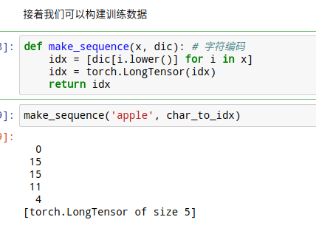

##### 1-1-2 一句话化单词编码

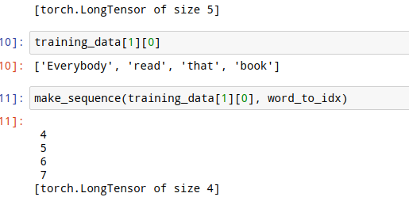

### 送数据模板

<http://localhost:8888/edit/pytorch-tutorial-junjey-master/tutorials/01-basics/pytorch_basics/main.py>

#===================== Input pipline for custom dataset =====================#  
# You should build custom dataset as below.  
class CustomDataset(data.Dataset):  
 def __init__(self):  
 # TODO  
 # 1. Initialize file path or list of file names.   
 pass  
 def __getitem__(self, index):  
 # TODO  
 # 1. Read one data from file (e.g. using numpy.fromfile, PIL.Image.open).  
 # 2. Preprocess the data (e.g. torchvision.Transform).  
 # 3. Return a data pair (e.g. image and label).  
 pass  
 def __len__(self):  
 # You should change 0 to the total size of your dataset.  
 return 0   
  
# Then, you can just use prebuilt torch's data loader.   
custom_dataset = CustomDataset()  
train_loader = torch.utils.data.DataLoader(dataset=custom_dataset,  
 batch_size=100,   
 shuffle=True,  
 num_workers=2)

# Data Loader (this provides queue and thread in a very simple way).  
train_loader = torch.utils.data.DataLoader(dataset=train_dataset,  
 batch_size=100,   
 shuffle=True,  
 num_workers=2)  
  
# When iteration starts, queue and thread start to load dataset from files.  
data_iter = iter(train_loader)  
  
# Mini-batch images and labels.  
images, labels = data_iter.next()  
  
# Actual usage of data loader is as below.  
for images, labels in train_loader:  
 # Your training code will be written here  
 pass

### Mnist数据

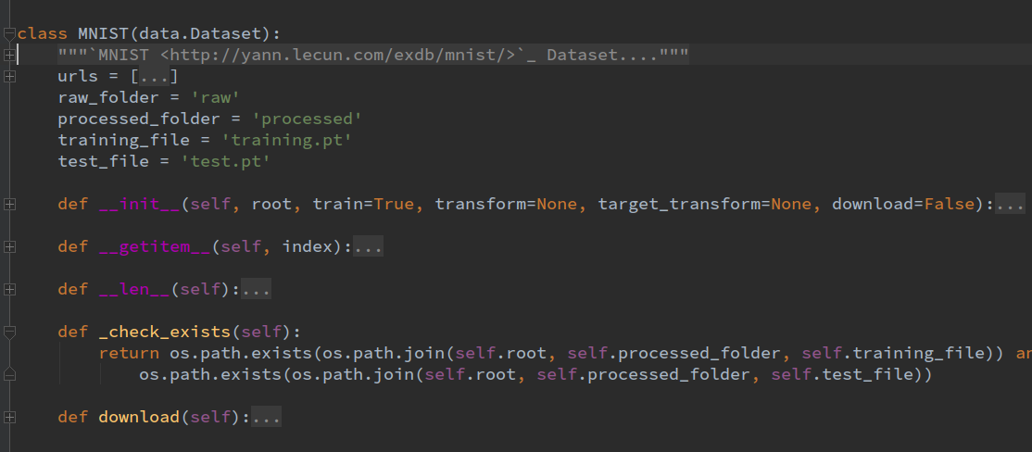

###### 1-最简单的tansform

import torchvision.datasets as dsets  
# MNIST Dataset  
train_dataset = dsets.MNIST(root='./data/',  
 train=True,   
 transform=transforms.ToTensor(),  
 download=True)  
  
test_dataset = dsets.MNIST(root='./data/',  
 train=False,   
 transform=transforms.ToTensor())  
  
  
# Data Loader (Input Pipeline)  
train_loader = torch.utils.data.DataLoader(dataset=train_dataset,  
 batch_size=batch_size,   
 shuffle=True)  
  
test_loader = torch.utils.data.DataLoader(dataset=test_dataset,  
 batch_size=batch_size,   
 shuffle=False)

2-这个transform没看懂

# 使用内置函数下载 mnist 数据集  
#train_set = mnist.MNIST('./data', train=True)  
#test_set = mnist.MNIST('./data', train=False)  
  
def data_tf(x):  
 x = np.array(x, dtype='float32') / 255  
 x = (x - 0.5) / 0.5 # 数据预处理，标准化  
 x = x.reshape((-1,)) # 拉平  
 x = torch.from_numpy(x)  
 return x  
  
train_set = mnist.MNIST('./data', train=True, transform=data_tf, download=True) # 重新载入数据集，申明定义的数据变换  
test_set = mnist.MNIST('./data', train=False, transform=data_tf, download=True)  
  
  
train_data = DataLoader(train_set, batch_size=64, shuffle=True)  
test_data = DataLoader(test_set, batch_size=128, shuffle=False)

### 模型

##### 0-写法原则

init中是类的实例化！ forward中 具体函数！

def conv3x3(in_channel, out_channel, stride=1):  
 return nn.Conv2d(in_channel, out_channel, 3, stride=stride, padding=1, bias=False)  
  
class residual_block(nn.Module):  
 def __init__(self, in_channel, out_channel, same_shape=True):  
 super(residual_block, self).__init__()  
 self.same_shape = same_shape  
 stride=1 if self.same_shape else 2  
   
 self.conv1 = conv3x3(in_channel, out_channel, stride=stride)  
 self.bn1 = nn.BatchNorm2d(out_channel)  
   
 self.conv2 = conv3x3(out_channel, out_channel)  
 self.bn2 = nn.BatchNorm2d(out_channel)  
 if not self.same_shape:  
 self.conv3 = nn.Conv2d(in_channel, out_channel, 1, stride=stride)  
   
 def forward(self, x):  
 out = self.conv1(x)  
 out = F.relu(self.bn1(out), True)  
 out = self.conv2(out)  
 out = F.relu(self.bn2(out), True)  
   
 if not self.same_shape:  
 x = self.conv3(x)  
 return F.relu(x+out, True)

##### 0-初始化

###### 1- 取出+用numpy改写法

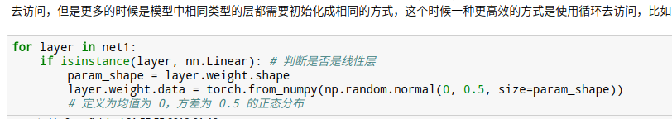

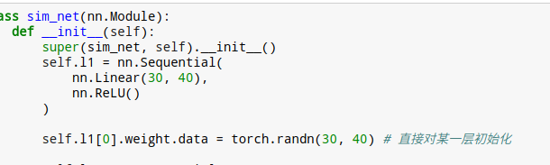

###### 2-torch.nn.init

###### Xavier

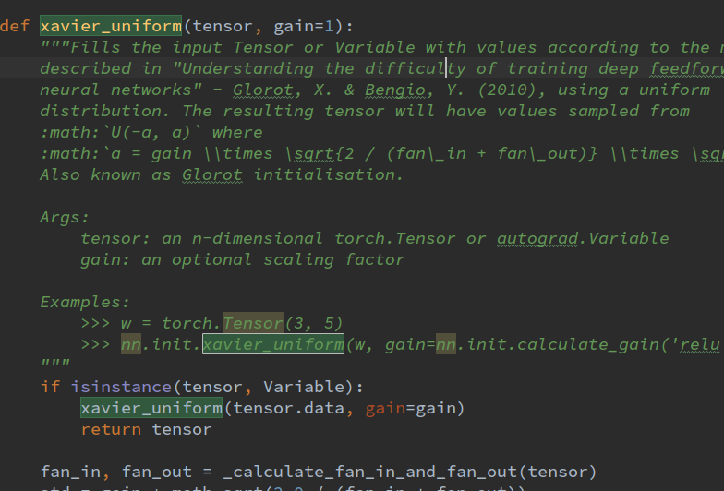

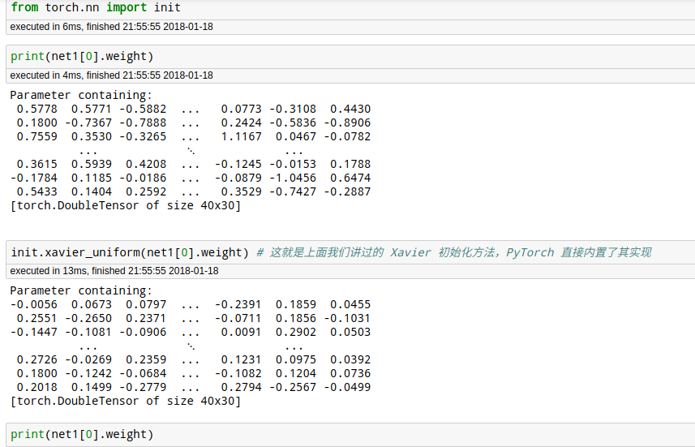

##### 0-2 droupout

##### 0-2 weight-decay[优化器]

<http://localhost:8888/notebooks/code-of-learn-deep-learning-with-pytorch-master/chapter4_CNN/regularization.ipynb>

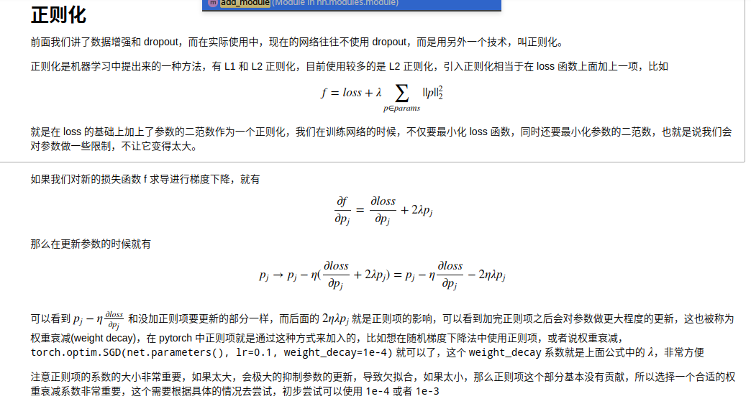



##### 0-3 lr-decay[训练，优化器]

##### 1-线性回归

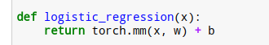

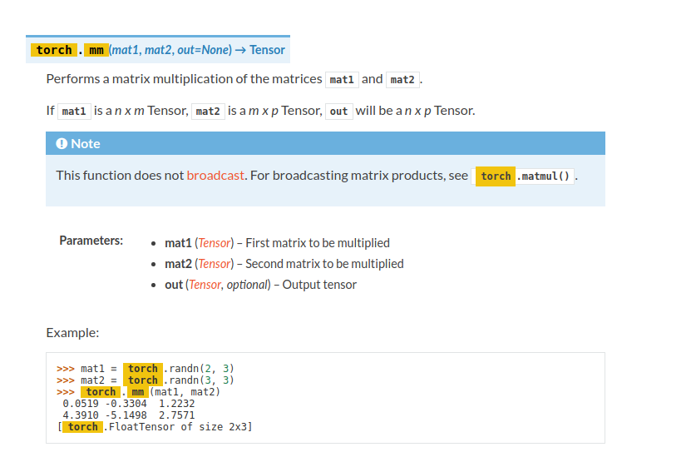

##### 2-手写二层网络

手写时，推荐用nn.Parameter

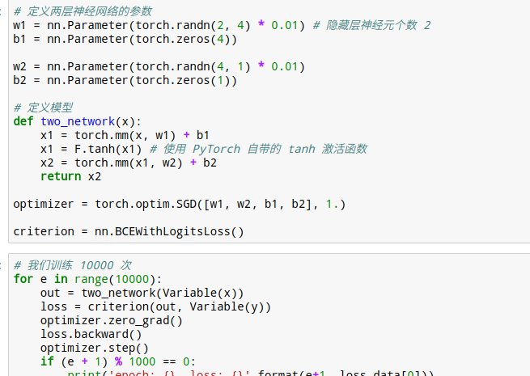

##### 2-1-二层网络+手写BN

gamma = torch.ones(x.shape[1])  
beta = torch.zeros(x.shape[1])

def batch_norm_1d(x, gamma, beta, is_training, moving_mean, moving_var, moving_momentum=0.1):  
 eps = 1e-5  
 x_mean = torch.mean(x, dim=0, keepdim=True) # 保留维度进行 broadcast  
 x_var = torch.mean((x - x_mean) ** 2, dim=0, keepdim=True)  
 if is_training:  
 x_hat = (x - x_mean) / torch.sqrt(x_var + eps)  
 moving_mean[:] = moving_momentum * moving_mean + (1. - moving_momentum) * x_mean  
 moving_var[:] = moving_momentum * moving_var + (1. - moving_momentum) * x_var  
 else:  
 x_hat = (x - moving_mean) / torch.sqrt(moving_var + eps)  
 return gamma.view_as(x_mean) * x_hat + beta.view_as(x_mean)

class multi_network(nn.Module):  
 def __init__(self):  
 super(multi_network, self).__init__()  
 self.layer1 = nn.Linear(784, 100)  
 self.relu = nn.ReLU(True)  
 self.layer2 = nn.Linear(100, 10)  
   
 self.gamma = nn.Parameter(torch.randn(100))  
 self.beta = nn.Parameter(torch.randn(100))  
   
 self.moving_mean = Variable(torch.zeros(100))  
 self.moving_var = Variable(torch.zeros(100))  
   
 def forward(self, x, is_train=True):  
 x = self.layer1(x)  
 x = batch_norm_1d(x, self.gamma, self.beta, is_train, self.moving_mean, self.moving_var)  
 x = self.relu(x)  
 x = self.layer2(x)  
 return x

#### CNN+

##### 3-二层cnn-mnist

###### 3-1 廖 cnn-bn

nn.ReLU(True),是否inplace,在Seq这个场景里，咩有区别

# 使用批标准化  
class conv_bn_net(nn.Module):  
 def __init__(self):  
 super(conv_bn_net, self).__init__()  
 self.stage1 = nn.Sequential(  
 nn.Conv2d(1, 6, 3, padding=1),  
 nn.BatchNorm2d(6),  
 nn.ReLU(True),  
 nn.MaxPool2d(2, 2),  
 nn.Conv2d(6, 16, 5),  
 nn.BatchNorm2d(16),  
 nn.ReLU(True),  
 nn.MaxPool2d(2, 2)  
 )  
   
 self.classfy = nn.Linear(400, 10)  
 def forward(self, x):  
 x = self.stage1(x)  
 x = x.view(x.shape[0], -1)  
 x = self.classfy(x)  
 return x  
  
net = conv_bn_net()  
optimizer = torch.optim.SGD(net.parameters(), 1e-1) # 使用随机梯度下降，学习率 0.1

###### 3-2 junjey:推荐

<http://localhost:8889/edit/pytorch-tutorial-junjey-master/tutorials/02-intermediate/convolutional_neural_network/main.py>

# CNN Model (2 conv layer)  
class CNN(nn.Module):  
 def __init__(self):  
 super(CNN, self).__init__()  
 self.layer1 = nn.Sequential(  
 nn.Conv2d(1, 16, kernel_size=5, padding=2),  
 nn.BatchNorm2d(16),  
 nn.ReLU(),  
 nn.MaxPool2d(2))  
 self.layer2 = nn.Sequential(  
 nn.Conv2d(16, 32, kernel_size=5, padding=2),  
 nn.BatchNorm2d(32),  
 nn.ReLU(),  
 nn.MaxPool2d(2))  
 self.fc = nn.Linear(7*7*32, 10)  
   
 def forward(self, x):  
 out = self.layer1(x)  
 out = self.layer2(out)  
 out = out.view(out.size(0), -1)  
 out = self.fc(out)  
 return out

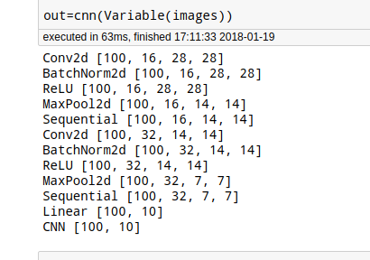

##### 4-vgg

最后有多层全连接！

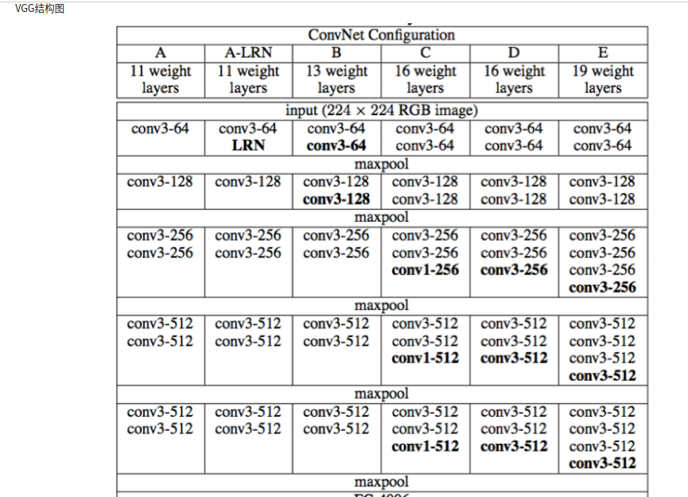

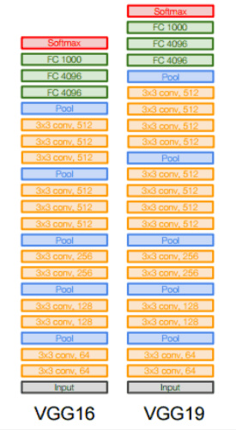

我觉得 self.feature = vgg_net 这一个写的不好。最好一个一个的block写会更直观！

class vgg(nn.Module):  
 def __init__(self):  
 super(vgg, self).__init__()  
 self.feature = vgg_net  
 self.fc = nn.Sequential(  
 nn.Linear(512, 100),  
 nn.ReLU(True),  
 nn.Linear(100, 10)  
 )  
 def forward(self, x):  
 x = self.feature(x)  
 x = x.view(x.shape[0], -1)  
 x = self.fc(x)  
 return x

一个block是 一堆黄色的conv+一个poll

vgg_stack是 block的累加，不带全连接

一个vgg是vgg_stack+全连接

因为block这个结构，经常用，所以就写成函数了

def vgg_block(num_convs, in_channels, out_channels):  
 net = [nn.Conv2d(in_channels, out_channels, kernel_size=3, padding=1), nn.ReLU(True)] # 定义第一层  
   
 for i in range(num_convs-1): # 定义后面的很多层  
 net.append(nn.Conv2d(out_channels, out_channels, kernel_size=3, padding=1))  
 net.append(nn.ReLU(True))  
   
 net.append(nn.MaxPool2d(2, 2)) # 定义池化层  
 return nn.Sequential(*net)

跟下面的写法类比，上面采取这种写法，更有利于for循环！！！！！！！！！

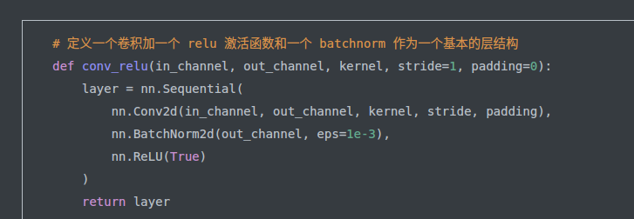

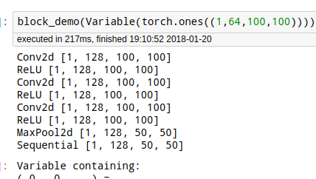

def vgg_stack(num_convs, channels):  
 net = []  
 for n, c in zip(num_convs, channels):  
 in_c = c[0]  
 out_c = c[1]  
 net.append(vgg_block(n, in_c, out_c))  
   
 return nn.Sequential(*net)  
  
  
  
vgg_net = vgg_stack((1, 1, 2, 2, 2), ((3, 64), (64, 128), (128, 256), (256, 512), (512, 512)))

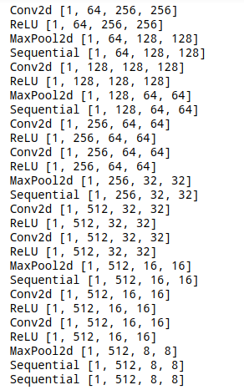

##### 5-googlenet

Inception堆叠，最后只有一个全连接！

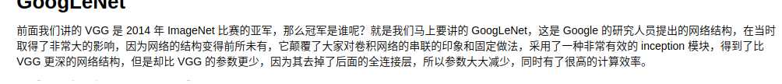

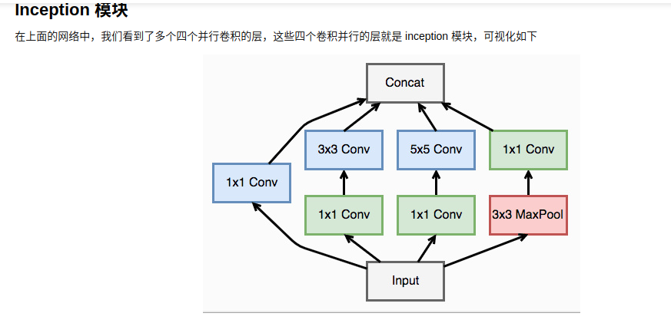

图像大小，不能有变化，否则最后没法，concat!!!!!!!!!!!!!!!!!!!!!!!!!!

大小收到stride 和padding控制

# 定义一个卷积加一个 relu 激活函数和一个 batchnorm 作为一个基本的层结构  
def conv_relu(in_channel, out_channel, kernel, stride=1, padding=0):  
 layer = nn.Sequential(  
 nn.Conv2d(in_channel, out_channel, kernel, stride, padding),  
 nn.BatchNorm2d(out_channel, eps=1e-3),  
 nn.ReLU(True)  
 )  
 return layer  
  
class inception(nn.Module):  
 def __init__(self, in_channel, out1_1, out2_1, out2_3, out3_1, out3_5, out4_1):  
 super(inception, self).__init__()  
 # 第一条线路  
 self.branch1x1 = conv_relu(in_channel, out1_1, 1)  
   
 # 第二条线路  
 self.branch3x3 = nn.Sequential(   
 conv_relu(in_channel, out2_1, 1),  
 conv_relu(out2_1, out2_3, 3, padding=1)  
 )  
   
 # 第三条线路  
 self.branch5x5 = nn.Sequential(  
 conv_relu(in_channel, out3_1, 1),  
 conv_relu(out3_1, out3_5, 5, padding=2)  
 )  
   
 # 第四条线路  
 self.branch_pool = nn.Sequential(  
 nn.MaxPool2d(3, stride=1, padding=1),  
 conv_relu(in_channel, out4_1, 1)  
 )  
   
 def forward(self, x):  
 f1 = self.branch1x1(x)  
 f2 = self.branch3x3(x)  
 f3 = self.branch5x5(x)  
 f4 = self.branch_pool(x)  
 output = torch.cat((f1, f2, f3, f4), dim=1)  
 return output

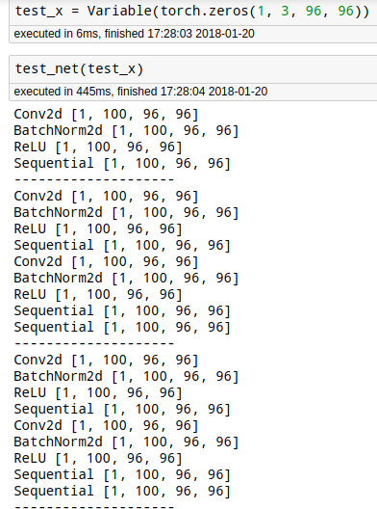

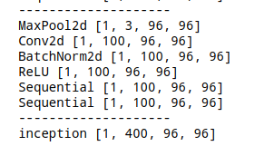

class googlenet(nn.Module):  
 def __init__(self, in_channel, num_classes, verbose=False):  
 super(googlenet, self).__init__()  
 self.verbose = verbose  
   
 self.block1 = nn.Sequential(  
 conv_relu(in_channel, out_channel=64, kernel=7, stride=2, padding=3),  
 nn.MaxPool2d(3, 2)  
 )  
   
 self.block2 = nn.Sequential(  
 conv_relu(64, 64, kernel=1),  
 conv_relu(64, 192, kernel=3, padding=1),  
 nn.MaxPool2d(3, 2)  
 )  
   
 self.block3 = nn.Sequential(  
 inception(192, 64, 96, 128, 16, 32, 32),  
 inception(256, 128, 128, 192, 32, 96, 64),  
 nn.MaxPool2d(3, 2)  
 )  
   
 self.block4 = nn.Sequential(  
 inception(480, 192, 96, 208, 16, 48, 64),  
 inception(512, 160, 112, 224, 24, 64, 64),  
 inception(512, 128, 128, 256, 24, 64, 64),  
 inception(512, 112, 144, 288, 32, 64, 64),  
 inception(528, 256, 160, 320, 32, 128, 128),  
 nn.MaxPool2d(3, 2)  
 )  
   
 self.block5 = nn.Sequential(  
 inception(832, 256, 160, 320, 32, 128, 128),  
 inception(832, 384, 182, 384, 48, 128, 128),  
 nn.AvgPool2d(2)  
 )  
   
 self.classifier = nn.Linear(1024, num_classes)  
   
 def forward(self, x):  
 x = self.block1(x)  
 if self.verbose:  
 print('--------------------------------------------block 1 output: {}'.format(x.shape))  
 x = self.block2(x)  
 if self.verbose:  
 print('--------------------------------------------block 2 output: {}'.format(x.shape))  
 x = self.block3(x)  
 if self.verbose:  
 print('--------------------------------------------block 3 output: {}'.format(x.shape))  
 x = self.block4(x)  
 if self.verbose:  
 print('--------------------------------------------block 4 output: {}'.format(x.shape))  
 x = self.block5(x)  
 if self.verbose:  
 print('--------------------------------------------block 5 output: {}'.format(x.shape))  
 x = x.view(x.shape[0], -1)  
 x = self.classifier(x)  
 return x

Conv2d [1, 64, 48, 48]  
BatchNorm2d [1, 64, 48, 48]  
ReLU [1, 64, 48, 48]  
Sequential [1, 64, 48, 48]  
MaxPool2d [1, 64, 23, 23]  
Sequential [1, 64, 23, 23]  
--------------------------------------------block 1 output: torch.Size([1, 64, 23, 23])  
Conv2d [1, 64, 23, 23]  
BatchNorm2d [1, 64, 23, 23]  
ReLU [1, 64, 23, 23]  
Sequential [1, 64, 23, 23]  
Conv2d [1, 192, 23, 23]  
BatchNorm2d [1, 192, 23, 23]  
ReLU [1, 192, 23, 23]  
Sequential [1, 192, 23, 23]  
MaxPool2d [1, 192, 11, 11]  
Sequential [1, 192, 11, 11]  
--------------------------------------------block 2 output: torch.Size([1, 192, 11, 11])  
Conv2d [1, 64, 11, 11]  
BatchNorm2d [1, 64, 11, 11]  
ReLU [1, 64, 11, 11]  
Sequential [1, 64, 11, 11]  
--------------------  
Conv2d [1, 96, 11, 11]  
BatchNorm2d [1, 96, 11, 11]  
ReLU [1, 96, 11, 11]  
Sequential [1, 96, 11, 11]  
Conv2d [1, 128, 11, 11]  
BatchNorm2d [1, 128, 11, 11]  
ReLU [1, 128, 11, 11]  
Sequential [1, 128, 11, 11]  
Sequential [1, 128, 11, 11]  
--------------------  
Conv2d [1, 16, 11, 11]  
BatchNorm2d [1, 16, 11, 11]  
ReLU [1, 16, 11, 11]  
Sequential [1, 16, 11, 11]  
Conv2d [1, 32, 11, 11]  
BatchNorm2d [1, 32, 11, 11]  
ReLU [1, 32, 11, 11]  
Sequential [1, 32, 11, 11]  
Sequential [1, 32, 11, 11]  
--------------------  
MaxPool2d [1, 192, 11, 11]  
Conv2d [1, 32, 11, 11]  
BatchNorm2d [1, 32, 11, 11]  
ReLU [1, 32, 11, 11]  
Sequential [1, 32, 11, 11]  
Sequential [1, 32, 11, 11]  
--------------------  
inception [1, 256, 11, 11]  
Conv2d [1, 128, 11, 11]  
BatchNorm2d [1, 128, 11, 11]  
ReLU [1, 128, 11, 11]  
Sequential [1, 128, 11, 11]  
--------------------  
Conv2d [1, 128, 11, 11]  
BatchNorm2d [1, 128, 11, 11]  
ReLU [1, 128, 11, 11]  
Sequential [1, 128, 11, 11]  
Conv2d [1, 192, 11, 11]  
BatchNorm2d [1, 192, 11, 11]  
ReLU [1, 192, 11, 11]  
Sequential [1, 192, 11, 11]  
Sequential [1, 192, 11, 11]  
--------------------  
Conv2d [1, 32, 11, 11]  
BatchNorm2d [1, 32, 11, 11]  
ReLU [1, 32, 11, 11]  
Sequential [1, 32, 11, 11]  
Conv2d [1, 96, 11, 11]  
BatchNorm2d [1, 96, 11, 11]  
ReLU [1, 96, 11, 11]  
Sequential [1, 96, 11, 11]  
Sequential [1, 96, 11, 11]  
--------------------  
MaxPool2d [1, 256, 11, 11]  
Conv2d [1, 64, 11, 11]  
BatchNorm2d [1, 64, 11, 11]  
ReLU [1, 64, 11, 11]  
Sequential [1, 64, 11, 11]  
Sequential [1, 64, 11, 11]  
--------------------  
inception [1, 480, 11, 11]  
MaxPool2d [1, 480, 5, 5]  
Sequential [1, 480, 5, 5]  
--------------------------------------------block 3 output: torch.Size([1, 480, 5, 5])  
Conv2d [1, 192, 5, 5]  
BatchNorm2d [1, 192, 5, 5]  
ReLU [1, 192, 5, 5]  
Sequential [1, 192, 5, 5]  
--------------------  
Conv2d [1, 96, 5, 5]  
BatchNorm2d [1, 96, 5, 5]  
ReLU [1, 96, 5, 5]  
Sequential [1, 96, 5, 5]  
Conv2d [1, 208, 5, 5]  
BatchNorm2d [1, 208, 5, 5]  
ReLU [1, 208, 5, 5]  
Sequential [1, 208, 5, 5]  
Sequential [1, 208, 5, 5]  
--------------------  
Conv2d [1, 16, 5, 5]  
BatchNorm2d [1, 16, 5, 5]  
ReLU [1, 16, 5, 5]  
Sequential [1, 16, 5, 5]  
Conv2d [1, 48, 5, 5]  
BatchNorm2d [1, 48, 5, 5]  
ReLU [1, 48, 5, 5]  
Sequential [1, 48, 5, 5]  
Sequential [1, 48, 5, 5]  
--------------------  
MaxPool2d [1, 480, 5, 5]  
Conv2d [1, 64, 5, 5]  
BatchNorm2d [1, 64, 5, 5]  
ReLU [1, 64, 5, 5]  
Sequential [1, 64, 5, 5]  
Sequential [1, 64, 5, 5]  
--------------------  
inception [1, 512, 5, 5]  
Conv2d [1, 160, 5, 5]  
BatchNorm2d [1, 160, 5, 5]  
ReLU [1, 160, 5, 5]  
Sequential [1, 160, 5, 5]  
--------------------  
Conv2d [1, 112, 5, 5]  
BatchNorm2d [1, 112, 5, 5]  
ReLU [1, 112, 5, 5]  
Sequential [1, 112, 5, 5]  
Conv2d [1, 224, 5, 5]  
BatchNorm2d [1, 224, 5, 5]  
ReLU [1, 224, 5, 5]  
Sequential [1, 224, 5, 5]  
Sequential [1, 224, 5, 5]  
--------------------  
Conv2d [1, 24, 5, 5]  
BatchNorm2d [1, 24, 5, 5]  
ReLU [1, 24, 5, 5]  
Sequential [1, 24, 5, 5]  
Conv2d [1, 64, 5, 5]  
BatchNorm2d [1, 64, 5, 5]  
ReLU [1, 64, 5, 5]  
Sequential [1, 64, 5, 5]  
Sequential [1, 64, 5, 5]  
--------------------  
MaxPool2d [1, 512, 5, 5]  
Conv2d [1, 64, 5, 5]  
BatchNorm2d [1, 64, 5, 5]  
ReLU [1, 64, 5, 5]  
Sequential [1, 64, 5, 5]  
Sequential [1, 64, 5, 5]  
--------------------  
inception [1, 512, 5, 5]  
Conv2d [1, 128, 5, 5]  
BatchNorm2d [1, 128, 5, 5]  
ReLU [1, 128, 5, 5]  
Sequential [1, 128, 5, 5]  
--------------------  
Conv2d [1, 128, 5, 5]  
BatchNorm2d [1, 128, 5, 5]  
ReLU [1, 128, 5, 5]  
Sequential [1, 128, 5, 5]  
Conv2d [1, 256, 5, 5]  
BatchNorm2d [1, 256, 5, 5]  
ReLU [1, 256, 5, 5]  
Sequential [1, 256, 5, 5]  
Sequential [1, 256, 5, 5]  
--------------------  
Conv2d [1, 24, 5, 5]  
BatchNorm2d [1, 24, 5, 5]  
ReLU [1, 24, 5, 5]  
Sequential [1, 24, 5, 5]  
Conv2d [1, 64, 5, 5]  
BatchNorm2d [1, 64, 5, 5]  
ReLU [1, 64, 5, 5]  
Sequential [1, 64, 5, 5]  
Sequential [1, 64, 5, 5]  
--------------------  
MaxPool2d [1, 512, 5, 5]  
Conv2d [1, 64, 5, 5]  
BatchNorm2d [1, 64, 5, 5]  
ReLU [1, 64, 5, 5]  
Sequential [1, 64, 5, 5]  
Sequential [1, 64, 5, 5]  
--------------------  
inception [1, 512, 5, 5]  
Conv2d [1, 112, 5, 5]  
BatchNorm2d [1, 112, 5, 5]  
ReLU [1, 112, 5, 5]  
Sequential [1, 112, 5, 5]  
--------------------  
Conv2d [1, 144, 5, 5]  
BatchNorm2d [1, 144, 5, 5]  
ReLU [1, 144, 5, 5]  
Sequential [1, 144, 5, 5]  
Conv2d [1, 288, 5, 5]  
BatchNorm2d [1, 288, 5, 5]  
ReLU [1, 288, 5, 5]  
Sequential [1, 288, 5, 5]  
Sequential [1, 288, 5, 5]  
--------------------  
Conv2d [1, 32, 5, 5]  
BatchNorm2d [1, 32, 5, 5]  
ReLU [1, 32, 5, 5]  
Sequential [1, 32, 5, 5]  
Conv2d [1, 64, 5, 5]  
BatchNorm2d [1, 64, 5, 5]  
ReLU [1, 64, 5, 5]  
Sequential [1, 64, 5, 5]  
Sequential [1, 64, 5, 5]  
--------------------  
MaxPool2d [1, 512, 5, 5]  
Conv2d [1, 64, 5, 5]  
BatchNorm2d [1, 64, 5, 5]  
ReLU [1, 64, 5, 5]  
Sequential [1, 64, 5, 5]  
Sequential [1, 64, 5, 5]  
--------------------  
inception [1, 528, 5, 5]  
Conv2d [1, 256, 5, 5]  
BatchNorm2d [1, 256, 5, 5]  
ReLU [1, 256, 5, 5]  
Sequential [1, 256, 5, 5]  
--------------------  
Conv2d [1, 160, 5, 5]  
BatchNorm2d [1, 160, 5, 5]  
ReLU [1, 160, 5, 5]  
Sequential [1, 160, 5, 5]  
Conv2d [1, 320, 5, 5]  
BatchNorm2d [1, 320, 5, 5]  
ReLU [1, 320, 5, 5]  
Sequential [1, 320, 5, 5]  
Sequential [1, 320, 5, 5]  
--------------------  
Conv2d [1, 32, 5, 5]  
BatchNorm2d [1, 32, 5, 5]  
ReLU [1, 32, 5, 5]  
Sequential [1, 32, 5, 5]  
Conv2d [1, 128, 5, 5]  
BatchNorm2d [1, 128, 5, 5]  
ReLU [1, 128, 5, 5]  
Sequential [1, 128, 5, 5]  
Sequential [1, 128, 5, 5]  
--------------------  
MaxPool2d [1, 528, 5, 5]  
Conv2d [1, 128, 5, 5]  
BatchNorm2d [1, 128, 5, 5]  
ReLU [1, 128, 5, 5]  
Sequential [1, 128, 5, 5]  
Sequential [1, 128, 5, 5]  
--------------------  
inception [1, 832, 5, 5]  
MaxPool2d [1, 832, 2, 2]  
Sequential [1, 832, 2, 2]  
--------------------------------------------block 4 output: torch.Size([1, 832, 2, 2])  
Conv2d [1, 256, 2, 2]  
BatchNorm2d [1, 256, 2, 2]  
ReLU [1, 256, 2, 2]  
Sequential [1, 256, 2, 2]  
--------------------  
Conv2d [1, 160, 2, 2]  
BatchNorm2d [1, 160, 2, 2]  
ReLU [1, 160, 2, 2]  
Sequential [1, 160, 2, 2]  
Conv2d [1, 320, 2, 2]  
BatchNorm2d [1, 320, 2, 2]  
ReLU [1, 320, 2, 2]  
Sequential [1, 320, 2, 2]  
Sequential [1, 320, 2, 2]  
--------------------  
Conv2d [1, 32, 2, 2]  
BatchNorm2d [1, 32, 2, 2]  
ReLU [1, 32, 2, 2]  
Sequential [1, 32, 2, 2]  
Conv2d [1, 128, 2, 2]  
BatchNorm2d [1, 128, 2, 2]  
ReLU [1, 128, 2, 2]  
Sequential [1, 128, 2, 2]  
Sequential [1, 128, 2, 2]  
--------------------  
MaxPool2d [1, 832, 2, 2]  
Conv2d [1, 128, 2, 2]  
BatchNorm2d [1, 128, 2, 2]  
ReLU [1, 128, 2, 2]  
Sequential [1, 128, 2, 2]  
Sequential [1, 128, 2, 2]  
--------------------  
inception [1, 832, 2, 2]  
Conv2d [1, 384, 2, 2]  
BatchNorm2d [1, 384, 2, 2]  
ReLU [1, 384, 2, 2]  
Sequential [1, 384, 2, 2]  
--------------------  
Conv2d [1, 182, 2, 2]  
BatchNorm2d [1, 182, 2, 2]  
ReLU [1, 182, 2, 2]  
Sequential [1, 182, 2, 2]  
Conv2d [1, 384, 2, 2]  
BatchNorm2d [1, 384, 2, 2]  
ReLU [1, 384, 2, 2]  
Sequential [1, 384, 2, 2]  
Sequential [1, 384, 2, 2]  
--------------------  
Conv2d [1, 48, 2, 2]  
BatchNorm2d [1, 48, 2, 2]  
ReLU [1, 48, 2, 2]  
Sequential [1, 48, 2, 2]  
Conv2d [1, 128, 2, 2]  
BatchNorm2d [1, 128, 2, 2]  
ReLU [1, 128, 2, 2]  
Sequential [1, 128, 2, 2]  
Sequential [1, 128, 2, 2]  
--------------------  
MaxPool2d [1, 832, 2, 2]  
Conv2d [1, 128, 2, 2]  
BatchNorm2d [1, 128, 2, 2]  
ReLU [1, 128, 2, 2]  
Sequential [1, 128, 2, 2]  
Sequential [1, 128, 2, 2]  
--------------------  
inception [1, 1024, 2, 2]  
AvgPool2d [1, 1024, 1, 1]  
Sequential [1, 1024, 1, 1]  
--------------------------------------------block 5 output: torch.Size([1, 1024, 1, 1])  
Linear [1, 10]  
googlenet [1, 10]  
Out[56]:  
Variable containing:  
 0.0154 -0.2038 -0.0850 0.1275 -0.1429 0.0751 -0.2173 0.0076 -0.0050 0.0496  
[torch.FloatTensor of size 1x10]  
In [ ]:

##### 6-resnet

<http://localhost:8888/notebooks/my-pytorch-tutorial/resnet.ipynb>

# 

注意体会 这个加法 和lstm有异曲同工之妙啊！！！！！！

+的时候，显然大小，通道数要一样。通道数要是不一样，就通过1卷积使得一样！

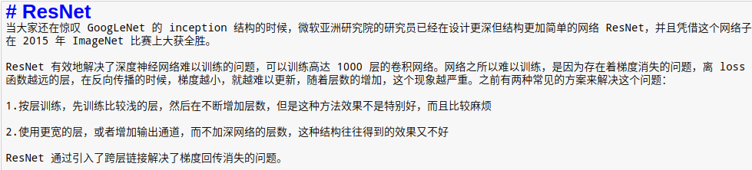

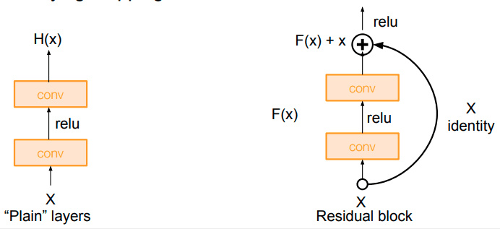

def conv3x3(in_channel, out_channel, stride=1):  
 return nn.Conv2d(in_channel, out_channel, 3, stride=stride, padding=1, bias=False)  
  
class residual_block(nn.Module):  
 def __init__(self, in_channel, out_channel, same_shape=True):  
 super(residual_block, self).__init__()  
 self.same_shape = same_shape  
 stride=1 if self.same_shape else 2  
   
 self.conv1 = conv3x3(in_channel, out_channel, stride=stride)  
 self.bn1 = nn.BatchNorm2d(out_channel)  
   
 self.conv2 = conv3x3(out_channel, out_channel)  
 self.bn2 = nn.BatchNorm2d(out_channel)  
 if not self.same_shape:  
 self.conv3 = nn.Conv2d(in_channel, out_channel, 1, stride=stride)  
   
 def forward(self, x):  
 out = self.conv1(x)  
 out = F.relu(self.bn1(out), True)  
 out = self.conv2(out)  
 out = F.relu(self.bn2(out), True)  
 #print('------out-------')  
   
 if not self.same_shape:  
 x = self.conv3(x)  
 return F.relu(x+out, True)

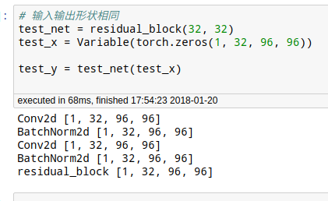

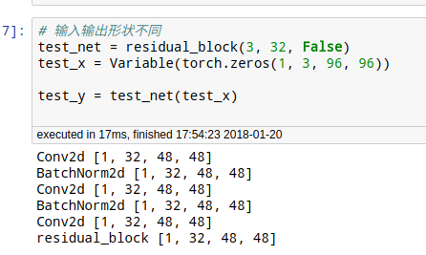

class resnet(nn.Module):  
 def __init__(self, in_channel, num_classes, verbose=False):  
 super(resnet, self).__init__()  
 self.verbose = verbose  
   
 self.block1 = nn.Conv2d(in_channel, 64, 7, 2)  
   
 self.block2 = nn.Sequential(  
 nn.MaxPool2d(3, 2),  
 residual_block(64, 64),  
 residual_block(64, 64)  
 )  
   
 self.block3 = nn.Sequential(  
 residual_block(64, 128, False),  
 residual_block(128, 128)  
 )  
   
 self.block4 = nn.Sequential(  
 residual_block(128, 256, False),  
 residual_block(256, 256)  
 )  
   
 self.block5 = nn.Sequential(  
 residual_block(256, 512, False),  
 residual_block(512, 512),  
 nn.AvgPool2d(3)  
 )  
   
 self.classifier = nn.Linear(512, num_classes)  
   
 def forward(self, x):  
 x = self.block1(x)  
 if self.verbose:  
 print('-------------------block 1 output: {}'.format(x.shape))  
 x = self.block2(x)  
 if self.verbose:  
 print('-------------------block 2 output: {}'.format(x.shape))  
 x = self.block3(x)  
 if self.verbose:  
 print('-------------------block 3 output: {}'.format(x.shape))  
 x = self.block4(x)  
 if self.verbose:  
 print('-------------------block 4 output: {}'.format(x.shape))  
 x = self.block5(x)  
 if self.verbose:  
 print('-------------------block 5 output: {}'.format(x.shape))  
 x = x.view(x.shape[0], -1)  
 x = self.classifier(x)  
 return x

##### 7-densenet



由resnet的+变为

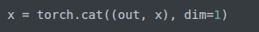

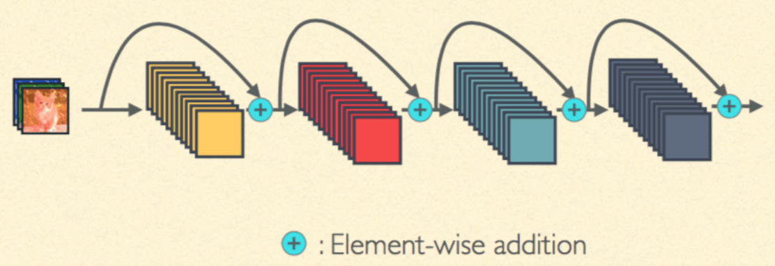

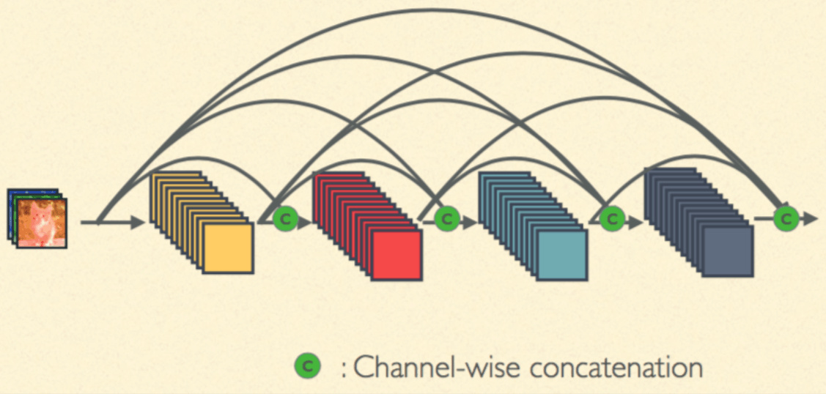

init中，只管定义，不管concat!

def conv_block(in_channel, out_channel):  
 layer = nn.Sequential(  
 nn.BatchNorm2d(in_channel),  
 nn.ReLU(True),  
 nn.Conv2d(in_channel, out_channel, 3, padding=1, bias=False)  
 )  
 return layer  
  
class dense_block(nn.Module):  
 def __init__(self, in_channel, growth_rate, num_layers):  
 super(dense_block, self).__init__()  
 block = []  
 channel = in_channel  
 for i in range(num_layers):  
 block.append(conv_block(channel, growth_rate))  
 channel += growth_rate  
   
 self.net = nn.Sequential(*block)  
   
 def forward(self, x):  
 for layer in self.net:  
 out = layer(x)  
 x = torch.cat((out, x), dim=1)  
 print('--------------------------------------')  
 return x

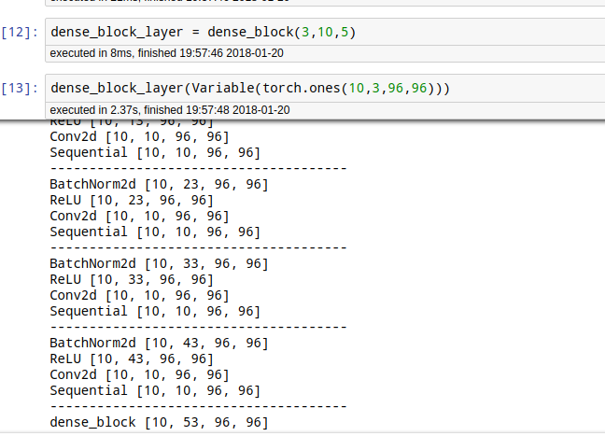



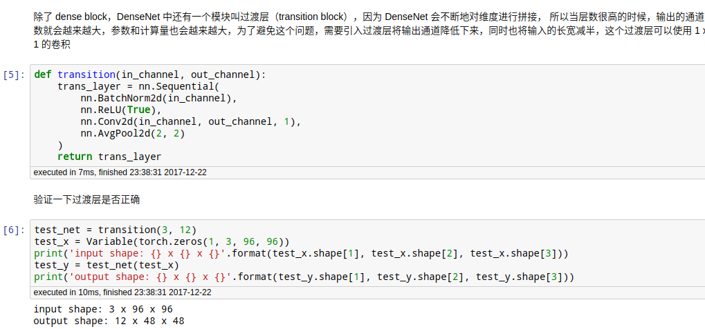

花式的block2写法！！！！！！！

def transition(in_channel, out_channel):  
 trans_layer = nn.Sequential(  
 nn.BatchNorm2d(in_channel),  
 nn.ReLU(True),  
 nn.Conv2d(in_channel, out_channel, 1),  
 nn.AvgPool2d(2, 2)  
 )  
 return trans_layer  
  
class densenet(nn.Module):  
 def __init__(self, in_channel, num_classes, growth_rate=32, block_layers=[6, 12, 24, 16]):  
 super(densenet, self).__init__()  
 self.block1 = nn.Sequential(  
 nn.Conv2d(in_channel, 64, 7, 2, 3),  
 nn.BatchNorm2d(64),  
 nn.ReLU(True),  
 nn.MaxPool2d(3, 2, padding=1)  
 )  
   
 channels = 64  
 block = []  
 for i, layers in enumerate(block_layers):  
 block.append(dense_block(channels, growth_rate, layers))  
 channels += layers * growth_rate  
 if i != len(block_layers) - 1:  
 block.append(transition(channels, channels // 2)) # 通过 transition 层将大小减半，通道数减半  
 channels = channels // 2  
   
 self.block2 = nn.Sequential(*block)  
 self.block2.add_module('bn', nn.BatchNorm2d(channels))  
 self.block2.add_module('relu', nn.ReLU(True))  
 self.block2.add_module('avg_pool', nn.AvgPool2d(3))  
   
 self.classifier = nn.Linear(channels, num_classes)  
   
 def forward(self, x):  
 x = self.block1(x)  
 x = self.block2(x)  
   
 x = x.view(x.shape[0], -1)  
 x = self.classifier(x)  
 return x

forward里面越简单，结构月不清晰！！！！！！！！！！！！！

打印出效果都不直观！！！！！！！！！

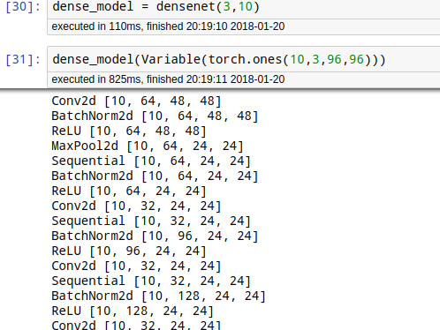

#### RNN

###### 0-手写RNN

<https://github.com/jamesdlut/practical-pytorch/tree/master/char-rnn-classification>

没有softmax我觉得就是真正的ＲＮＮ了

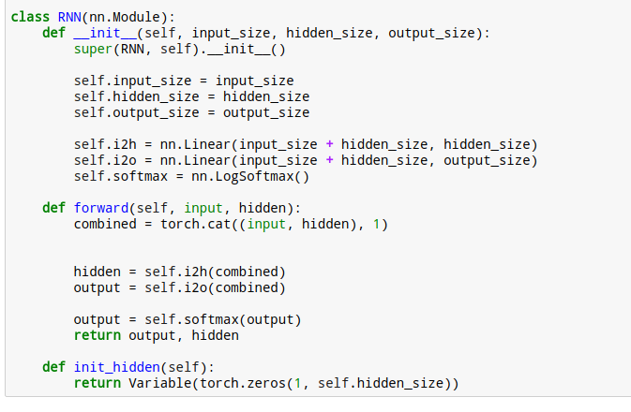

###### 1-RNN_Cell

注意输入变量的结构！！！！

[序列长度，batch_size,元素大小]

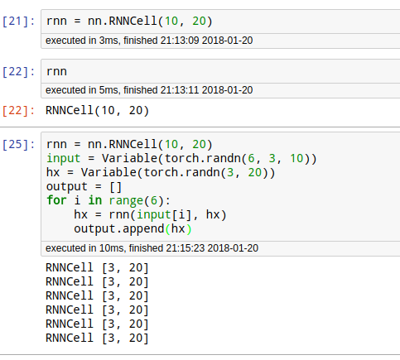

###### 2-RNN （输入维度，隐层维度，）

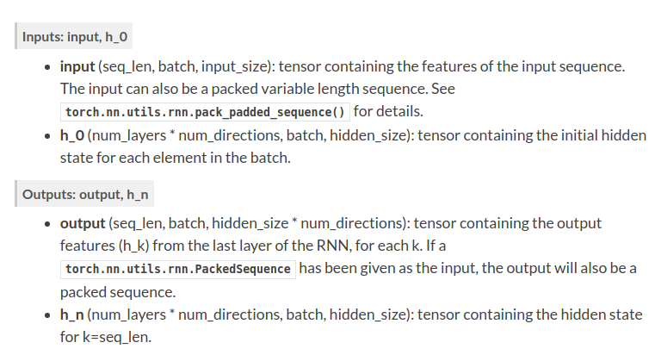

第三个参数是隐藏层的层数！

input【序列长度，batch,元素长度】

output，是所有环节的输出！！！！！

hn只是最后一个环节的隐状态

记忆单元部分可以不写！

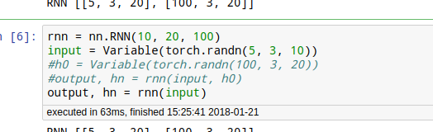

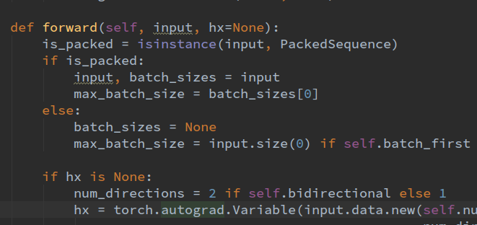

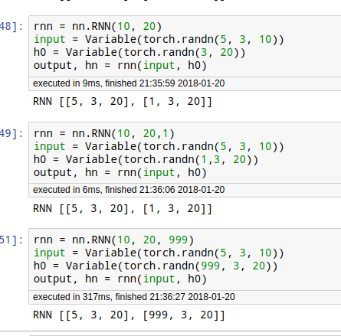

###### 2-LSTMCELL：多了C0长时记忆单元

唯一的区别就是多出了长时间记忆单元！！！！！！！！！！！！！！！C0

h0是短时，记忆单元

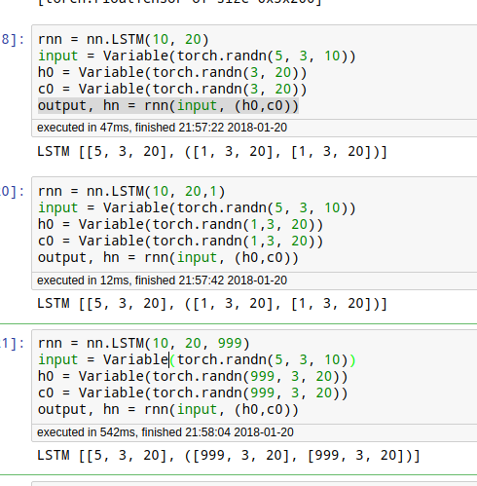

###### 3-GRU：用法和RNN一样

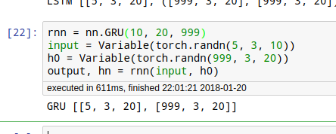

###### 4-rnn-minst

# 定义模型  
class rnn_classify(nn.Module):  
 def __init__(self, in_feature=28, hidden_feature=100, num_class=10, num_layers=2):  
 super(rnn_classify, self).__init__()  
 self.rnn = nn.LSTM(in_feature, hidden_feature, num_layers) # 使用两层 lstm  
 self.classifier = nn.Linear(hidden_feature, num_class) # 将最后一个 rnn 的输出使用全连接得到最后的分类结果  
   
 def forward(self, x):  
 '''  
 x 大小为 (batch, 1, 28, 28)，所以我们需要将其转换成 RNN 的输入形式，即 (28, batch, 28)  
 '''  
 x = x.squeeze() # 去掉 (batch, 1, 28, 28) 中的 1，变成 (batch, 28, 28)  
 x = x.permute(2, 0, 1) # 将最后一维放到第一维，变成 (28, batch, 28)  
 out, _ = self.rnn(x) # 使用默认的隐藏状态，得到的 out 是 (28, batch, hidden_feature)  
 print(out.shape)  
 out = out[-1, :, :] # 取序列中的最后一个，大小是 (batch, hidden_feature)  
 out = self.classifier(out) # 得到分类结果  
 return out

###### 5-时间预测序列。强两个月预测后一个月

<http://localhost:8890/notebooks/code-of-learn-deep-learning-with-pytorch-master/chapter5_RNN/time-series/lstm-time-series.ipynb>

# 定义模型  
class lstm_reg(nn.Module):  
 def __init__(self, input_size, hidden_size, output_size=1, num_layers=2):  
 super(lstm_reg, self).__init__()  
   
 self.rnn = nn.LSTM(input_size, hidden_size, num_layers) # rnn  
 self.reg = nn.Linear(hidden_size, output_size) # 回归  
   
 def forward(self, x):  
 x, _ = self.rnn(x) # (seq, batch, hidden)  
 s, b, h = x.shape  
 x = x.view(s*b, h) # 转换成线性层的输入格式  
 x = self.reg(x)  
 x = x.view(s, b, -1)  
 return x

注意1：过任何函数，只能多出来一个batch size。所以这里先变成二维度，再变成三维！！

x = x.view(s*b, h) # 转换成线性层的输入格式  
 x = self.reg(x)  
 x = x.view(s, b, -1)

注意2：rnn(x),h0,c0可以不写！

#### NLP

##### 1-词向量

注意 取多个单词变量的写法！！！

10个单词，每个单词维度是3

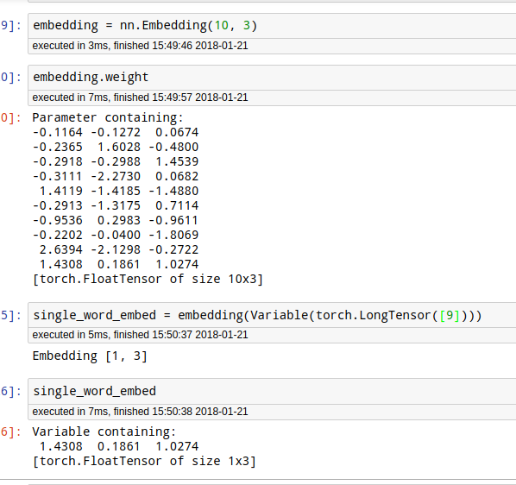

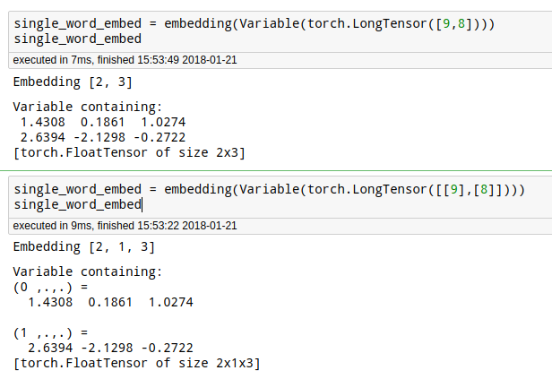

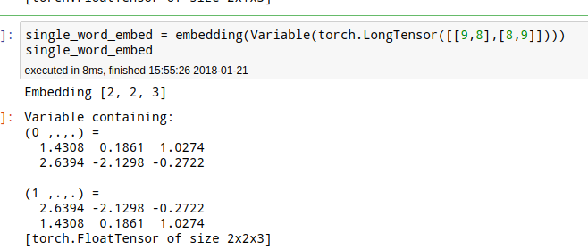

##### 2-3元语法模型，前两个单词预测下一个单词

<http://localhost:8890/notebooks/code-of-learn-deep-learning-with-pytorch-master/chapter5_RNN/nlp/n-gram.ipynb>

# 定义模型  
class n_gram(nn.Module):  
 def __init__(self, vocab_size, context_size=CONTEXT_SIZE, n_dim=EMBEDDING_DIM):  
 super(n_gram, self).__init__()  
   
 self.embed = nn.Embedding(vocab_size, n_dim)  
 self.classify = nn.Sequential(  
 nn.Linear(context_size * n_dim, 128),  
 nn.ReLU(True),  
 nn.Linear(128, vocab_size)  
 )  
   
 def forward(self, x):  
 voc_embed = self.embed(x) # 得到词嵌入  
 voc_embed = voc_embed.view(1, -1) # 将两个词向量拼在一起  
 #print('voc_embed:',list(voc_embed.shape))  
 out = self.classify(voc_embed)  
 return out

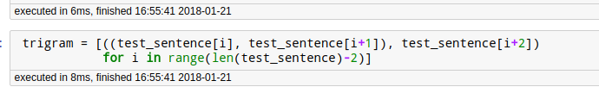

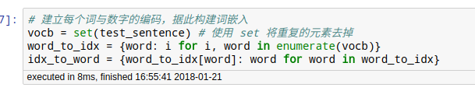

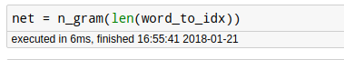

##### ２-文本分类－英文西班牙文－逻辑回归-CBOW(词袋法)

<http://localhost:8890/notebooks/1-my-pytorch-tutorial/NLP/%EF%BC%92-%E6%96%87%E6%9C%AC%E5%88%86%E7%B1%BB%EF%BC%8D%E8%8B%B1%E6%96%87%E8%A5%BF%E7%8F%AD%E7%89%99%E6%96%87%EF%BC%8D%E9%80%BB%E8%BE%91%E5%9B%9E%E5%BD%92-CBOW>(%E8%AF%8D%E8%A2%8B%E6%B3%95).ipynb



class BoWClassifier(nn.Module): # inheriting from nn.Module!  
   
 def __init__(self, num_labels, vocab_size):  
 # calls the init function of nn.Module. Dont get confused by syntax,  
 # just always do it in an nn.Module  
 super(BoWClassifier, self).__init__()  
   
 # Define the parameters that you will need. In this case, we need A and b,  
 # the parameters of the affine mapping.  
 # Torch defines nn.Linear(), which provides the affine map.  
 # Make sure you understand why the input dimension is vocab_size  
 # and the output is num_labels!  
 self.linear = nn.Linear(vocab_size, num_labels)  
   
 # NOTE! The non-linearity log softmax does not have parameters! So we don't need  
 # to worry about that here  
   
 def forward(self, bow_vec):  
 # Pass the input through the linear layer,  
 # then pass that through log_softmax.  
 # Many non-linearities and other functions are in torch.nn.functional  
 return F.log_softmax(self.linear(bow_vec))

##### ２－１各国人名分类－手写RNN 字符级 onehot

###### 结果

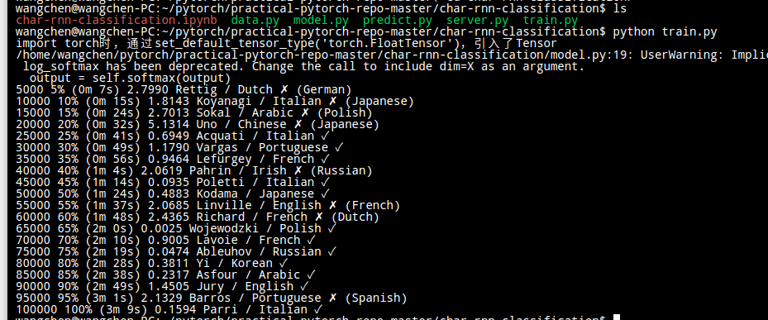

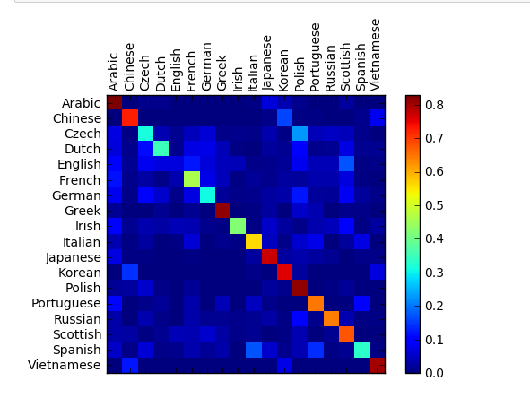

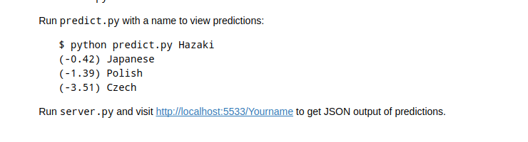

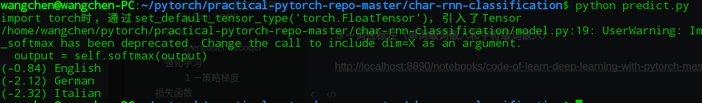

###### 网页上看结果

NLP  
  
1-词向量  
  
注意 取多个单词变量的写法！！！  
  
10个单词，每个单词维度是3  
  
  
  
  
  
  
  
  
2-3元语法模型，前两个单词预测下一个单词  
  
http://localhost:8890/notebooks/code-of-learn-deep-learning-with-pytorch-master/chapter5_RNN/nlp/n-gram.ipynb  
  
   
  
# 定义模型  
class n_gram(nn.Module):  
    def __init__(self, vocab_size, context_size=CONTEXT_SIZE, n_dim=EMBEDDING_DIM):  
        super(n_gram, self).__init__()  
          
        self.embed = nn.Embedding(vocab_size, n_dim)  
        self.classify = nn.Sequential(  
            nn.Linear(context_size * n_dim, 128),  
            nn.ReLU(True),  
            nn.Linear(128, vocab_size)  
       )  
          
    def forward(self, x):  
        voc_embed = self.embed(x) # 得到词嵌入  
        voc_embed = voc_embed.view(1, -1) # 将两个词向量拼在一起  
        #print('voc_embed:',list(voc_embed.shape))  
        out = self.classify(voc_embed)  
        return out  
  
  
  
  
  
  
  
  
  
２-文本分类－英文西班牙文－逻辑回归-CBOW(词袋法)  
  
http://localhost:8890/notebooks/1-my-pytorch-tutorial/NLP/%EF%BC%92-%E6%96%87%E6%9C%AC%E5%88%86%E7%B1%BB%EF%BC%8D%E8%8B%B1%E6%96%87%E8%A5%BF%E7%8F%AD%E7%89%99%E6%96%87%EF%BC%8D%E9%80%BB%E8%BE%91%E5%9B%9E%E5%BD%92-CBOW(%E8%AF%8D%E8%A2%8B%E6%B3%95).ipynb  
  
 xxxxxxxxxx from bottle import route, runfrom predict import *@route('/<input_line>')def index(input_line):    return {'result': predict(input_line, 10)}run(host='localhost', port=5533)

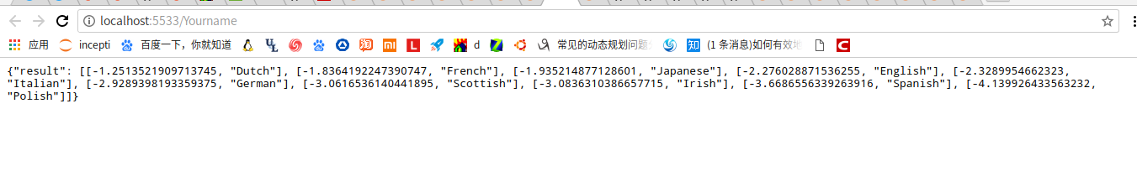

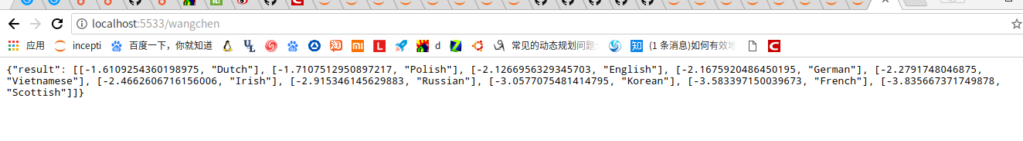

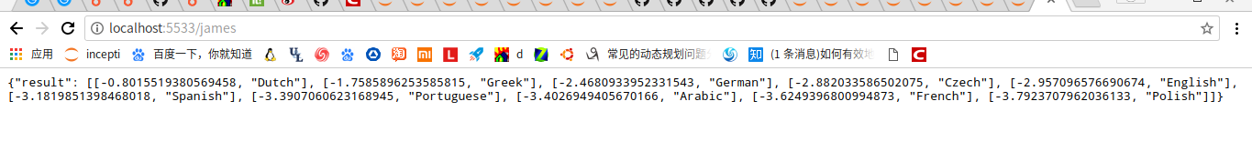

##### ３－词性标注（单词级词嵌入和字符级词嵌入）

<http://localhost:8890/notebooks/code-of-learn-deep-learning-with-pytorch-master/chapter5_RNN/nlp/seq-lstm.ipynb>``

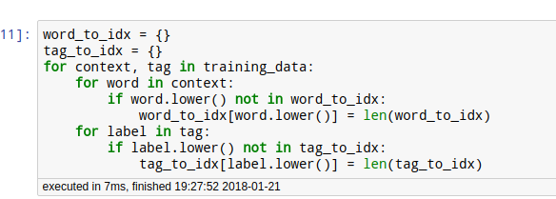

#char_dim, #10  
#char_hidden,#50  
#self.char_lstm = char_lstm(n_char, char_dim, char_hidden)  
class char_lstm(nn.Module):  
 def __init__(self, n_char, char_dim, char_hidden):  
 super(char_lstm, self).__init__()  
   
 self.char_embed = nn.Embedding(n_char, char_dim)  
 self.lstm = nn.LSTM(char_dim, char_hidden)  
   
 def forward(self, x):  
 x = self.char_embed(x)  
 out, _ = self.lstm(x)  
 return out[-1] # (batch, hidden)

class lstm_tagger(nn.Module):  
 #net = lstm_tagger(len(word_to_idx), len(char_to_idx), 10, 100, 50, 128, len(tag_to_idx))  
 def __init__(self,  
 n_word,#len(word_to_idx)  
 n_char, #len(char_to_idx)  
 char_dim, #10  
 word_dim, #100  
 char_hidden,#50  
 word_hidden,#128  
 n_tag#en(tag_to_idx)  
 ):  
 super(lstm_tagger, self).__init__()  
 self.word_embed = nn.Embedding(n_word, word_dim)  
 self.char_lstm = char_lstm(n_char, char_dim, char_hidden)  
 self.word_lstm = nn.LSTM(word_dim + char_hidden, word_hidden)  
 self.classify = nn.Linear(word_hidden, n_tag)　  
   
 #out = net(word_list, word)  
   
 def forward(self, x, word):  
 # word_list　4　5　6　7 用于单词级别  
 # word ("The dog ate the apple".split()　用于字符级别['The', 'dog', 'ate', 'the', 'apple']  
  
   
 #1 单词中每个字符的词嵌入  
 char = []  
 for w in word: # 对于每个单词做字符的 lstm  
 char_list = make_sequence(w, char_to_idx)  
 char_list = char_list.unsqueeze(1) # (seq, batch, feature) 满足 lstm 输入条件  
 char_infor = self.char_lstm(Variable(char_list)) # (batch, char_hidden)  
 char.append(char_infor)  
 char = torch.stack(char, dim=0) # (seq, batch, feature) # stack是维度是多出来，和cat不一样  
   
 #2 单词的词嵌入  
 w.unsqueeze(1)   
 x = self.word_embed(x) # (batch, seq, word_dim) #([1, 5, 100])  
 x = x.permute(1, 0, 2) # 改变顺序 #[5,1,100]  
   
 #3 字符级＋单次级  
 x = torch.cat((x, char), dim=2) # 沿着特征通道将每个词的词嵌入和字符 lstm 输出的结果拼接在一起  
 x, _ = self.word_lstm(x)  
   
 s, b, h = x.shape  
 x = x.view(-1, h) # 重新 reshape 进行分类线性层  
 out = self.classify(x)  
 return out

###### CRF４－命名实体识别 bi-lstm +CRF

#### GAN

###### 1-encoder decoder

<http://localhost:8890/notebooks/code-of-learn-deep-learning-with-pytorch-master/chapter6_GAN/autoencoder.ipynb>

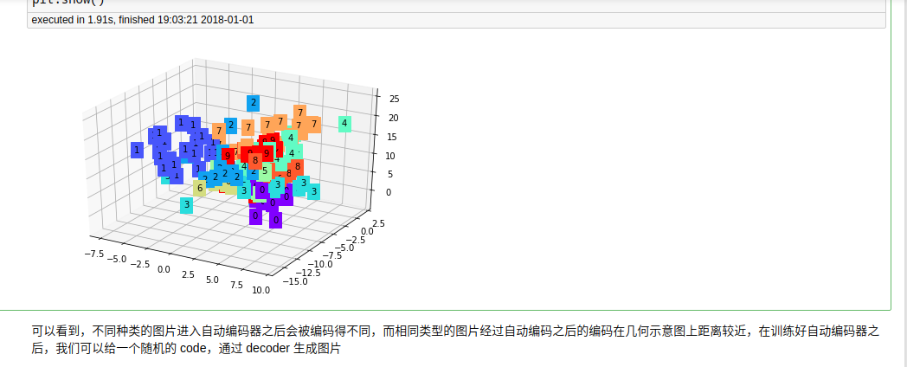

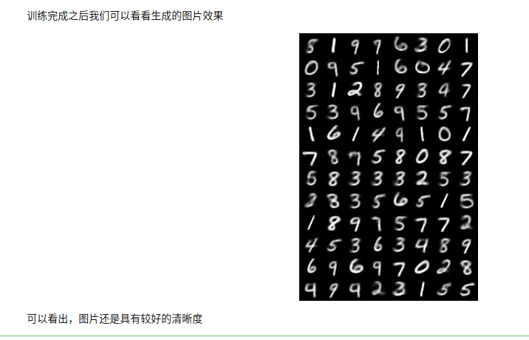

# 定义网络  
class Autoencoder(nn.Module):  
 def __init__(self):  
 super(Autoencoder, self).__init__()  
   
 self.encoder = nn.Sequential(  
 nn.Linear(28*28, 128),  
 nn.ReLU(True),  
 nn.Linear(128, 64),  
 nn.ReLU(True),  
 nn.Linear(64, 12),  
 nn.ReLU(True),  
 nn.Linear(12, 3) # 输出的 code 是 3 维，便于可视化  
 )  
   
 self.decoder = nn.Sequential(  
 nn.Linear(3, 12),  
 nn.ReLU(True),  
 nn.Linear(12, 64),  
 nn.ReLU(True),  
 nn.Linear(64, 128),  
 nn.ReLU(True),  
 nn.Linear(128, 28*28),  
 nn.Tanh() #  
 )  
  
 def forward(self, x):  
 encode = self.encoder(x)  
 #print('------------------------------')  
 decode = self.decoder(encode)  
 return encode, decode



class conv_autoencoder(nn.Module):  
 def __init__(self):  
 super(conv_autoencoder, self).__init__()  
   
 self.encoder = nn.Sequential(  
 nn.Conv2d(1, 16, 3, stride=3, padding=1), # (b, 16, 10, 10)  
 nn.ReLU(True),  
 nn.MaxPool2d(2, stride=2), # (b, 16, 5, 5)  
 nn.Conv2d(16, 8, 3, stride=2, padding=1), # (b, 8, 3, 3)  
 nn.ReLU(True),  
 nn.MaxPool2d(2, stride=1) # (b, 8, 2, 2)  
 )  
   
 self.decoder = nn.Sequential(  
 nn.ConvTranspose2d(8, 16, 3, stride=2), # (b, 16, 5, 5)  
 nn.ReLU(True),  
 nn.ConvTranspose2d(16, 8, 5, stride=3, padding=1), # (b, 8, 15, 15)  
 nn.ReLU(True),  
 nn.ConvTranspose2d(8, 1, 2, stride=2, padding=1), # (b, 1, 28, 28)  
 nn.Tanh()  
 )  
  
 def forward(self, x):  
 encode = self.encoder(x)  
 decode = self.decoder(encode)  
 return encode, decode

###### 2-VAE 隐层是正太分布，重参数技巧

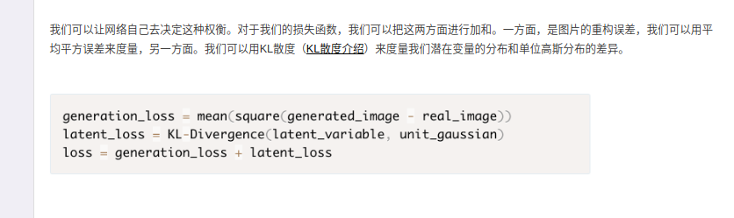

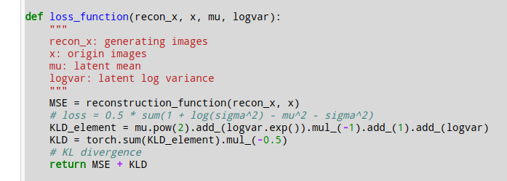

<http://localhost:8888/notebooks/code-of-learn-deep-learning-with-pytorch-master/chapter6_GAN/vae.ipynb>

<https://zhuanlan.zhihu.com/p/25269592>

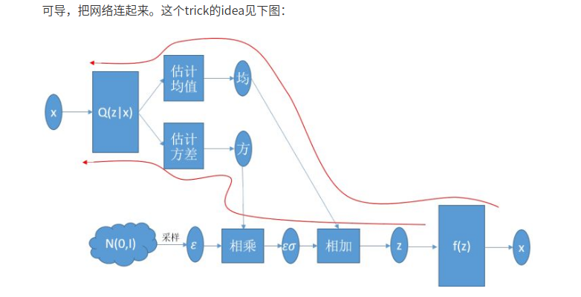

###### ３－ＧＡＮ

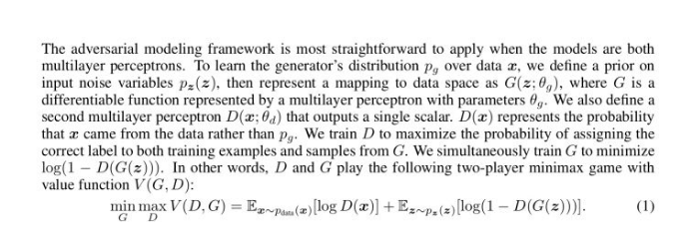

这个其实并不直观。这个关于JS散度！

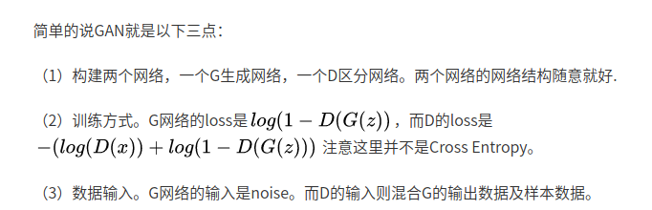

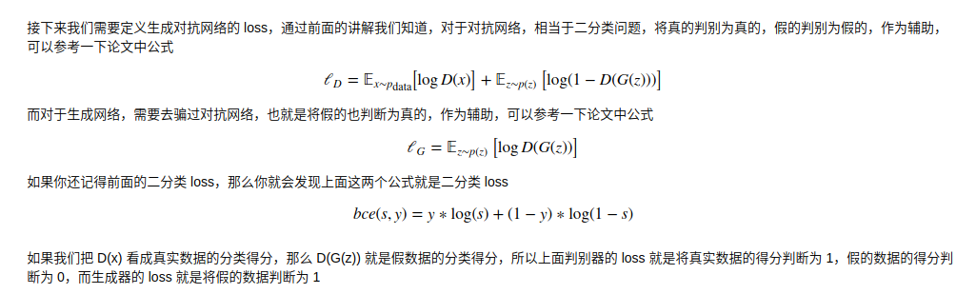

#### 强化学习

###### １－策略梯度

### 损失函数

###### 0-loss中的size_average





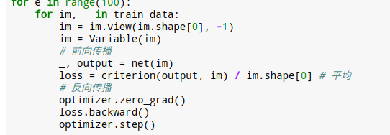

###### 1-二分类交叉熵

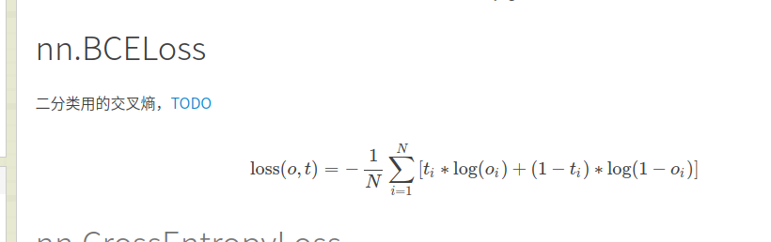

criterion = nn.BCEWithLogitsLoss()

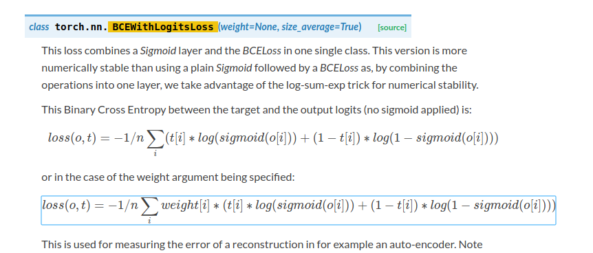

###### 2-nll与cross entropy

区别 input的位置，有没有logsoftmax，本质都是一种损失

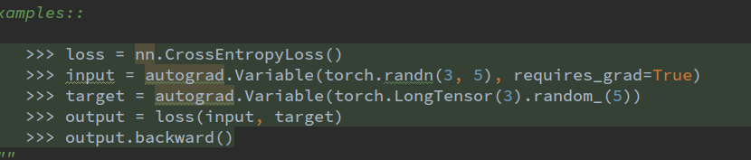

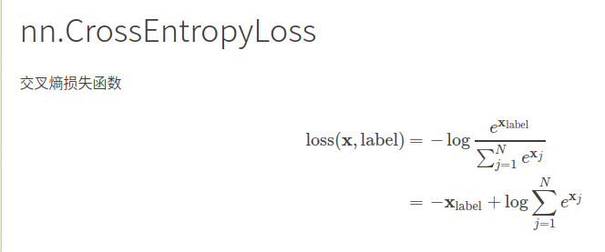

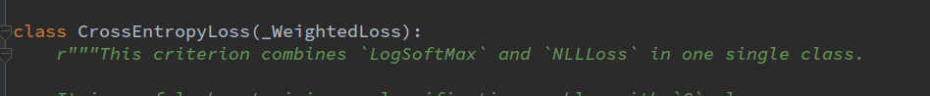

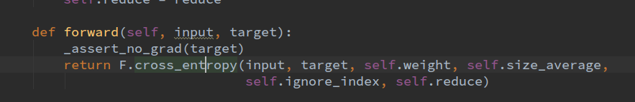





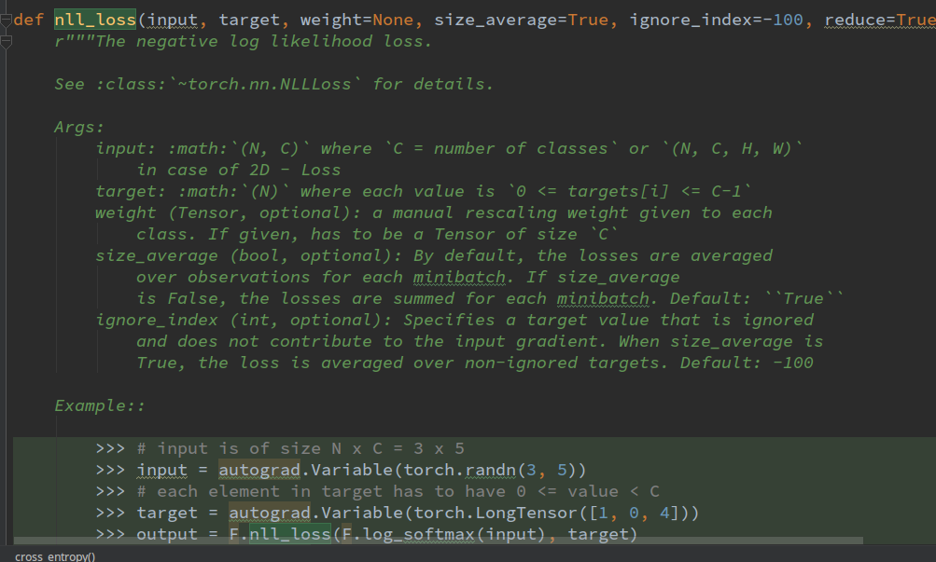

### 优化器

##### 0-Optimizer

把传来的param，和lr等其他信息组成一个param_group。

什么时候用多个groups?

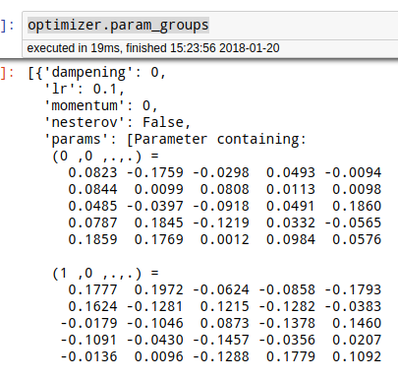

###### 0-1 optimizer.zero_grad()

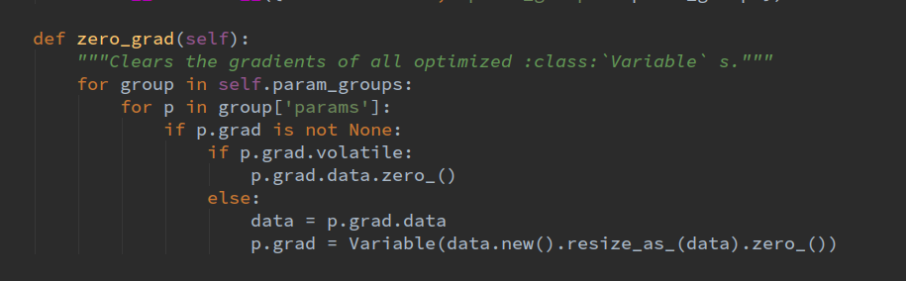

类比

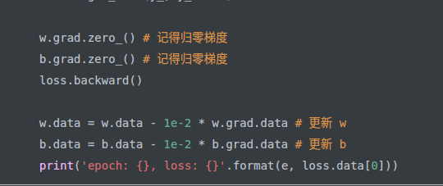

###### optimizer的param_group和defaults

param_group理解

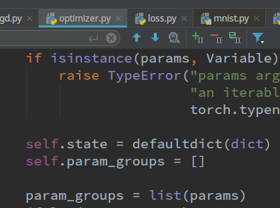

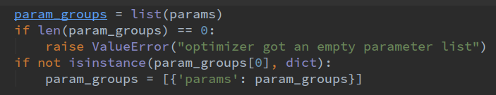

转化为dict的样子

网络的参数

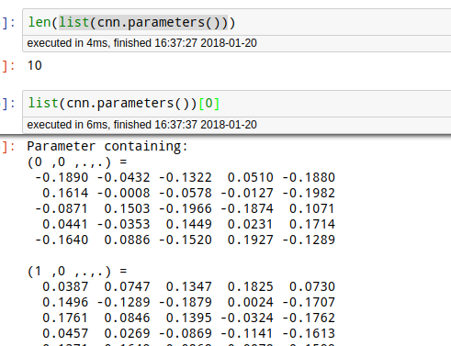

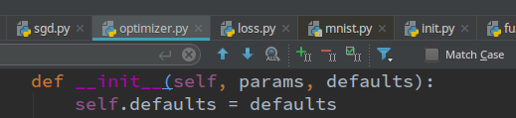

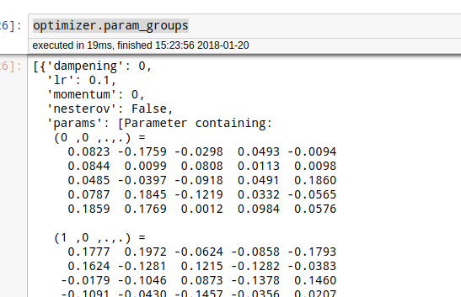

###### 0-1 lr-decay[训练]

###### 0-2 weight-decay





##### 1-SGD

<http://localhost:8891/notebooks/code-of-learn-deep-learning-with-pytorch-master/chapter3_NN/nn-sequential-module.ipynb>

optimizer = torch.optim.SGD([w, b], 1e-1)

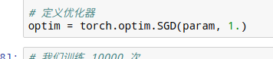

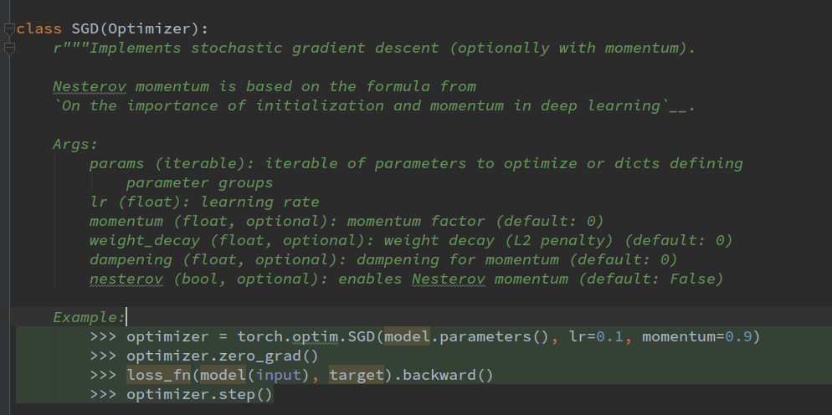

###### 1-optimizer.step

类比

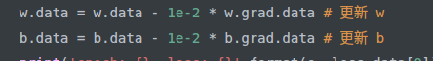

##### 2-Adam

# Loss and Optimizer  
criterion = nn.CrossEntropyLoss()  
optimizer = torch.optim.Adam(cnn.parameters(), lr=learning_rate)

### train

###### 1-1

<http://localhost:8891/notebooks/code-of-learn-deep-learning-with-pytorch-master/chapter3_NN/linear-regression-gradient-descend.ipynb>

# loss.data[0]纯数据

for e in range(10): # 进行 10 次更新  
 y_ = linear_model(x_train)  
 loss = get_loss(y_, y_train)  
   
 w.grad.zero_() # 记得归零梯度  
 b.grad.zero_() # 记得归零梯度  
 loss.backward()  
   
 w.data = w.data - 1e-2 * w.grad.data # 更新 w  
 b.data = b.data - 1e-2 * b.grad.data # 更新 b   
 print('epoch: {}, loss: {}'.format(e, loss.data[0]))

###### 1-2

for e in range(100):  
 out = logistic_regression(Variable(x))  
 loss = criterion(out, Variable(y))  
 optimizer.zero_grad()  
 loss.backward()  
 optimizer.step()  
 if (e + 1) % 20 == 0:  
 print('epoch: {}, loss: {}'.format(e+1, loss.data[0]))

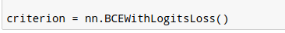

# 我们训练 10000 次  
for e in range(10000):  
 out = seq_net(Variable(x))  
 loss = criterion(out, Variable(y))  
 optim.zero_grad()  
 loss.backward()  
 optim.step()  
 if (e + 1) % 1000 == 0:  
 print('epoch: {}, loss: {}'.format(e+1, loss.data[0]))

###### 1-3 junjey-cnn-train

两个optimizer夹着loss.backward。

# loss.data[0] 纯数据！

其他顺序不限

<http://localhost:8889/edit/pytorch-tutorial-junjey-master/tutorials/02-intermediate/convolutional_neural_network/main.py>

criterion = nn.CrossEntropyLoss()  
  
# Train the Model  
for epoch in range(num_epochs):  
 for i, (images, labels) in enumerate(train_loader):  
 images = Variable(images)  
 labels = Variable(labels)  
   
 # Forward + Backward + Optimize  
 optimizer.zero_grad()  
 outputs = cnn(images)  
 loss = criterion(outputs, labels)  
 loss.backward()  
 optimizer.step()  
   
 if (i+1) % 100 == 0:  
 print ('Epoch [%d/%d], Iter [%d/%d] Loss: %.4f'   
 %(epoch+1, num_epochs, i+1, len(train_dataset)//batch_size, loss.data[0]))

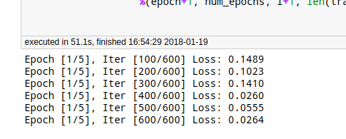

###### 1-4 zero-to-all-cnn-mnist

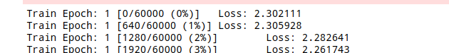

这个train是带了参数的，epoch代表是第几个epoch!

loss.data[0] 提取到了纯数据！

def train(epoch):  
 model.train()  
 for batch_idx, (data, target) in enumerate(train_loader):  
 data, target = Variable(data), Variable(target)  
 optimizer.zero_grad()  
 output = model(data)  
 loss = F.nll_loss(output, target)  
 loss.backward()  
 optimizer.step()  
 if batch_idx % 10 == 0:  
 print('Train Epoch: {} [{}/{} ({:.0f}%)]\tLoss: {:.6f}'.format(  
 epoch, batch_idx * len(data), len(train_loader.dataset),  
 100. * batch_idx / len(train_loader), loss.data[0]))

###### 3-廖星宇utils.train

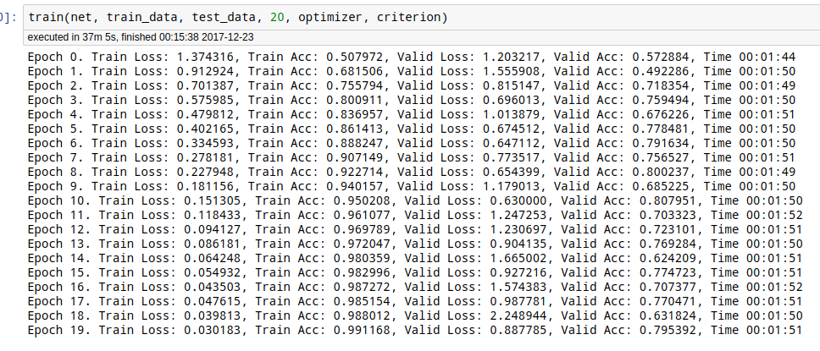

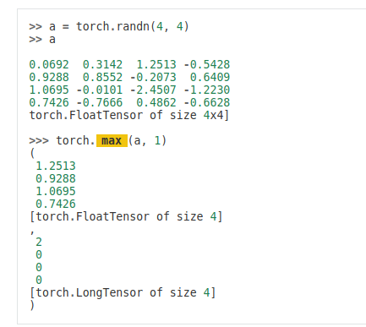

def get_acc(output, label):  
 total = output.shape[0]  
 _, pred_label = output.max(1)  
 num_correct = (pred_label == label).sum().data[0]  
 return num_correct / total

def train(net, train_data, valid_data, num_epochs, optimizer, criterion):  
 if torch.cuda.is_available():  
 net = net.cuda()  
 prev_time = datetime.now()  
 for epoch in range(num_epochs):  
 train_loss = 0  
 train_acc = 0  
 net = net.train()  
 for im, label in train_data:  
 if torch.cuda.is_available():  
 im = Variable(im.cuda()) # (bs, 3, h, w)  
 label = Variable(label.cuda()) # (bs, h, w)  
 else:  
 im = Variable(im)  
 label = Variable(label)  
 # forward  
 output = net(im)  
 loss = criterion(output, label)  
 # backward  
 optimizer.zero_grad()  
 loss.backward()  
 optimizer.step()  
  
 train_loss += loss.data[0]  
 train_acc += get_acc(output, label)  
  
 cur_time = datetime.now()  
 h, remainder = divmod((cur_time - prev_time).seconds, 3600)  
 m, s = divmod(remainder, 60)  
 time_str = "Time %02d:%02d:%02d" % (h, m, s)  
 if valid_data is not None:  
 valid_loss = 0  
 valid_acc = 0  
 net = net.eval()  
 for im, label in valid_data:  
 if torch.cuda.is_available():  
 im = Variable(im.cuda(), volatile=True)  
 label = Variable(label.cuda(), volatile=True)  
 else:  
 im = Variable(im, volatile=True)  
 label = Variable(label, volatile=True)  
 output = net(im)  
 loss = criterion(output, label)  
 valid_loss += loss.data[0]  
 valid_acc += get_acc(output, label)  
 epoch_str = (  
 "Epoch %d. Train Loss: %f, Train Acc: %f, Valid Loss: %f, Valid Acc: %f, "  
 % (epoch, train_loss / len(train_data),  
 train_acc / len(train_data), valid_loss / len(valid_data),  
 valid_acc / len(valid_data)))  
 else:  
 epoch_str = ("Epoch %d. Train Loss: %f, Train Acc: %f, " %  
 (epoch, train_loss / len(train_data),  
 train_acc / len(train_data)))  
 prev_time = cur_time  
 print(epoch_str + time_str)

3-廖星宇 train+lr decay

没有上面的好，除了这句话！！！！！！！！

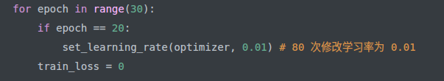

train_losses = []  
valid_losses = []  
  
if torch.cuda.is_available():  
 net = net.cuda()  
prev_time = datetime.now()  
for epoch in range(30):  
 if epoch == 20:  
 set_learning_rate(optimizer, 0.01) # 80 次修改学习率为 0.01  
 train_loss = 0  
  
   
 net = net.train()  
 for im, label in train_data:  
 if torch.cuda.is_available():  
 im = Variable(im.cuda()) # (bs, 3, h, w)  
 label = Variable(label.cuda()) # (bs, h, w)  
 else:  
 im = Variable(im)  
 label = Variable(label)  
 # forward  
 output = net(im)  
 loss = criterion(output, label)  
 # backward  
 optimizer.zero_grad()  
 loss.backward()  
 optimizer.step()  
  
 train_loss += loss.data[0]  
 cur_time = datetime.now()  
 h, remainder = divmod((cur_time - prev_time).seconds, 3600)  
 m, s = divmod(remainder, 60)  
 time_str = "Time %02d:%02d:%02d" % (h, m, s)  
 valid_loss = 0  
 valid_acc = 0  
   
   
 net = net.eval()  
 for im, label in valid_data:  
 if torch.cuda.is_available():  
 im = Variable(im.cuda(), volatile=True)  
 label = Variable(label.cuda(), volatile=True)  
 else:  
 im = Variable(im, volatile=True)  
 label = Variable(label, volatile=True)  
 output = net(im)  
 loss = criterion(output, label)  
 valid_loss += loss.data[0]  
 epoch_str = (  
 "Epoch %d. Train Loss: %f, Valid Loss: %f, "  
 % (epoch, train_loss / len(train_data), valid_loss / len(valid_data)))  
 prev_time = cur_time  
   
 train_losses.append(train_loss / len(train_data))  
 valid_losses.append(valid_loss / len(valid_data))  
 print(epoch_str + time_str)

###### 4-GAN-自编码器

# 开始训练自动编码器  
for e in range(40):  
 for im, _ in train_data:  
 if torch.cuda.is_available():  
 im = im.cuda()  
 im = Variable(im)  
 # 前向传播  
 _, output = conv_net(im)  
 loss = criterion(output, im) / im.shape[0] # 平均  
 # 反向传播  
 optimizer.zero_grad()  
 loss.backward()  
 optimizer.step()  
   
 if (e+1) % 20 == 0: # 每 20 次，将生成的图片保存一下  
 print('epoch: {}, Loss: {:.4f}'.format(e+1, loss.data[0]))  
 pic = to_img(output.cpu().data)  
 if not os.path.exists('./conv_autoencoder'):  
 os.mkdir('./conv_autoencoder')  
 save_image(pic, './conv_autoencoder/image_{}.png'.format(e+1))

def to_img(x):  
 '''  
 定义一个函数将最后的结果转换回图片  
 '''  
 x = 0.5 * (x + 1.)  
 x = x.clamp(0, 1)  
 x = x.view(x.shape[0], 1, 28, 28)  
 return x

### test

##### 0-细节

###### 0-1torch.max vs Tensor.max

我觉得 tensor_A.max（,） == torch.max(tensor_A,)



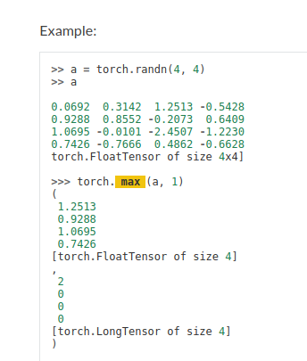



我觉得 tensor_A.max（,） == torch.max(tensor_A,)

###### 0-2 correct + sum()



空间 element-wise 判断

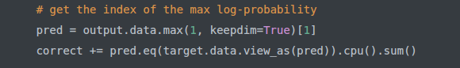

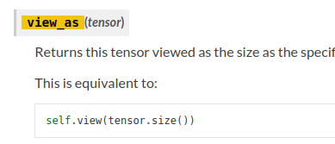

必须要 view as 变成同一种 空间结构，否则可能要“广播""引起错误

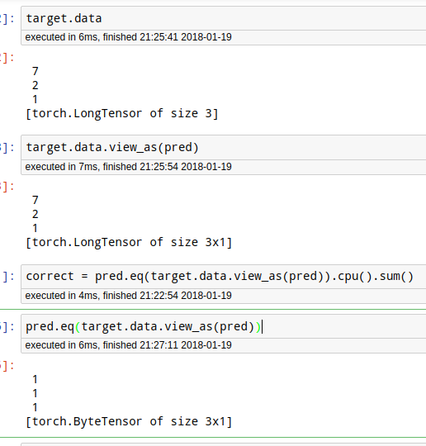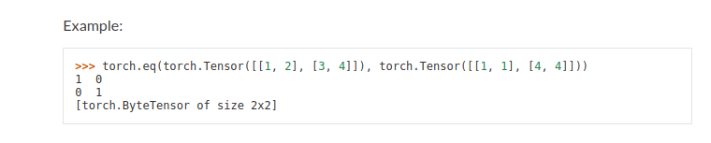

##### 1-junjey-cnn-没有loss

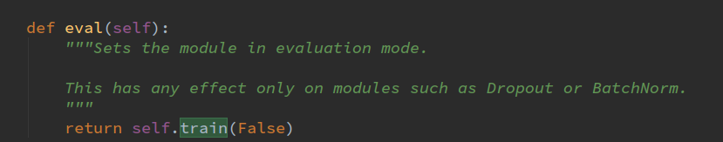

# Test the Model  
cnn.eval() # Change model to 'eval' mode (BN uses moving mean/var).  
correct = 0  
total = 0  
for images, labels in test_loader:  
 images = Variable(images)  
 outputs = cnn(images)  
 _, predicted = torch.max(outputs.data, 1)  
 total += labels.size(0)  
 correct += (predicted == labels).sum()  
  
print('Test Accuracy of the model on the 10000 test images: %d %%' % (100 * correct / total))  
  
# Save the Trained Model  
torch.save(cnn.state_dict(), 'cnn.pkl')

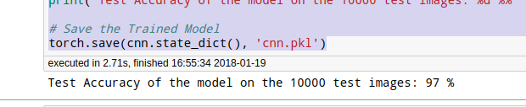

##### 2-zero-to-all-cnn-mnist:有loss

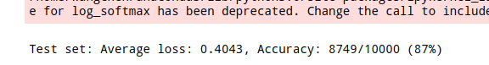

def test():  
 model.eval()  
 test_loss = 0  
 correct = 0  
 for data, target in test_loader:  
 data, target = Variable(data, volatile=True), Variable(target)  
 # volatile=True 相当于不要梯度  
 output = model(data)  
 # sum up batch loss  
 test_loss += F.nll_loss(output, target, size_average=False).data[0]  
 # get the index of the max log-probability  
 pred = output.data.max(1, keepdim=True)[1]  
 correct += pred.eq(target.data.view_as(pred)).cpu().sum()  
  
 test_loss /= len(test_loader.dataset)  
 print('\nTest set: Average loss: {:.4f}, Accuracy: {}/{} ({:.0f}%)\n'.format(  
 test_loss, correct, len(test_loader.dataset),  
 100. * correct / len(test_loader.dataset)))  
  
  
for epoch in range(1, 10):  
 train(epoch)  
 test()

### 保存模型

###### 1-模型参数都保存 t

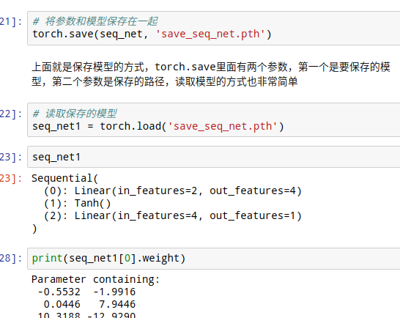

###### 2-只保存参数（推荐）

比较

net = torch.load('')

net.load_static_dict(torch.load(""))

.pth vs .pickle

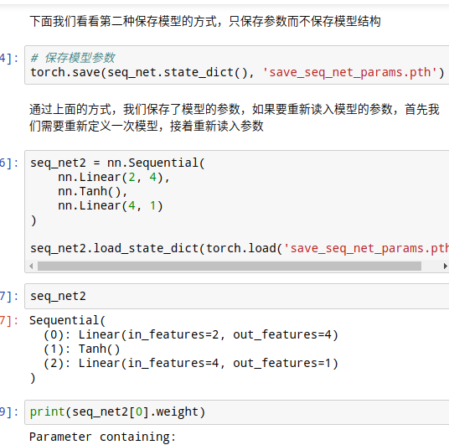

# Save the Trained Model  
torch.save(cnn.state_dict(), 'cnn.pkl')

## 教程

### 一 pytorch基础

#### 1-Tensor

<http://pytorch.org/docs/0.3.0/tensors.html>

##### 1-源码

###### import torch

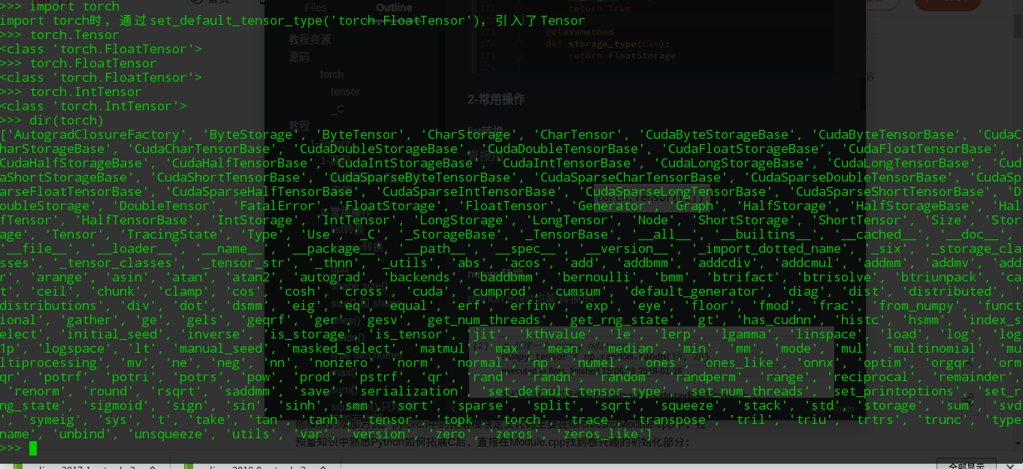

###### 多重继承：有C中过来的

###### 

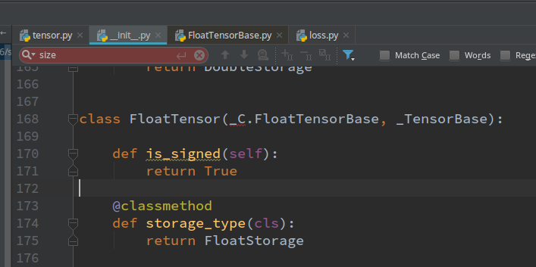

##### 2-常用操作

###### torch.Tensor(list或numpy) 推荐

list转换 numpy也可以。直接就是floatTensor。所以比from_numpy好

直接用



###### torch.from_numpy(numpy) 不推荐

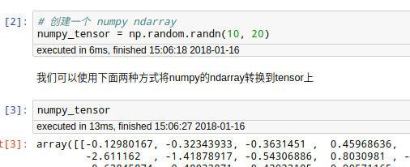

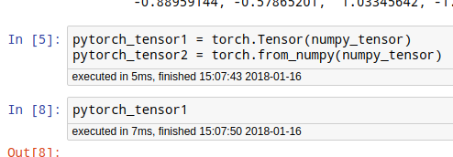

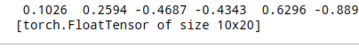

###### torch$tensor.numpy()

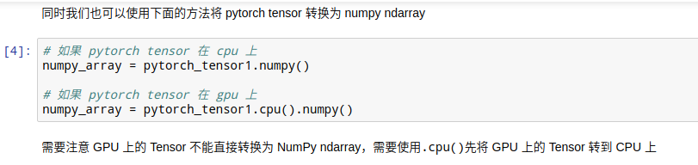

###### torch$tensor.tolist

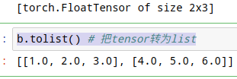

torch$tensor.cuda()

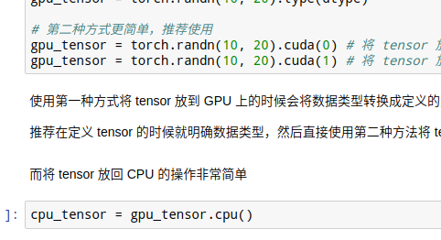

###### torch$tensor.shape

###### torch$tensor.size()

!1516087422293](pytorch截图/1516087422293.png)

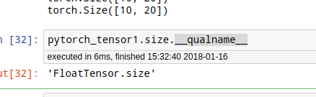

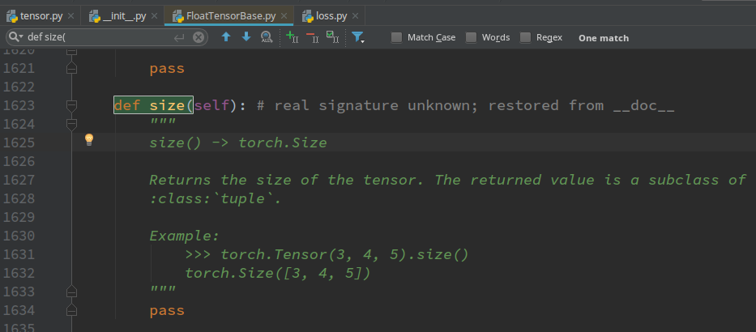

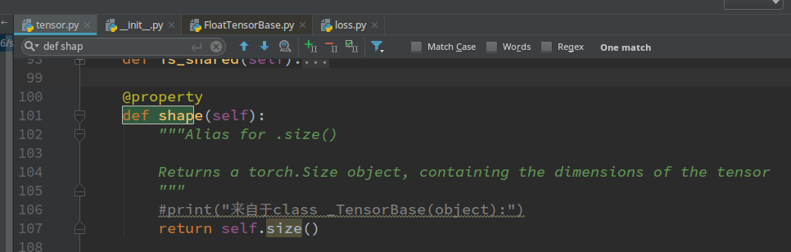

###### torch.ones()

触碰到C语言了

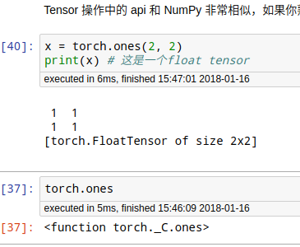

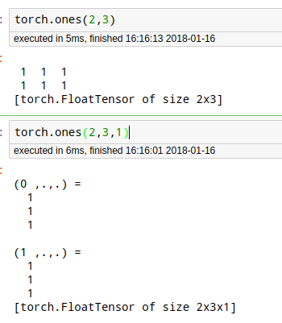

注意这种多于2维的写法



###### torch$tensor.add_ () 等inplace操作 与numpy共享

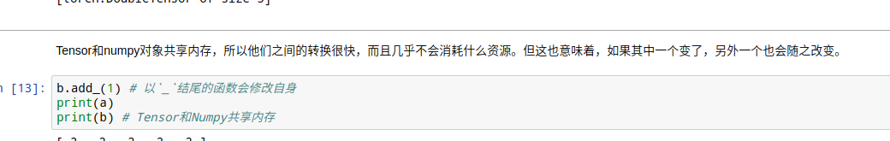

###### torch.randn(3,2)

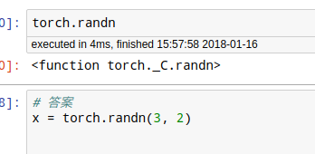

###### type dim numel

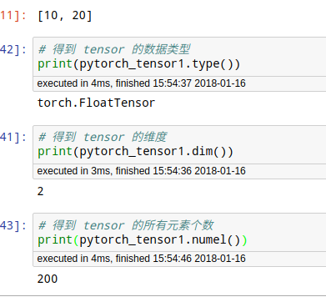

###### max()：既返数值，又返回位置！

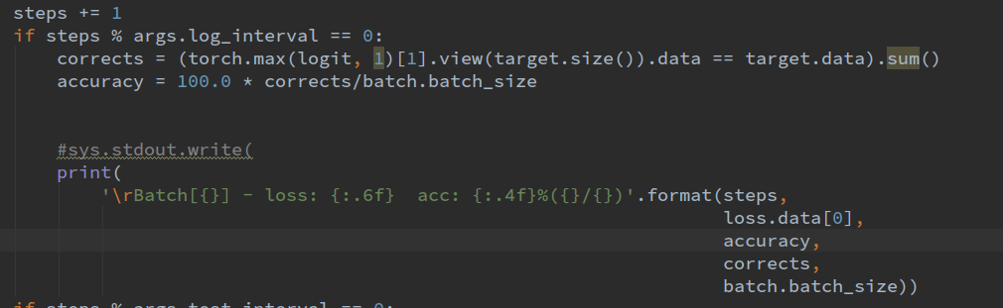

用于正确率

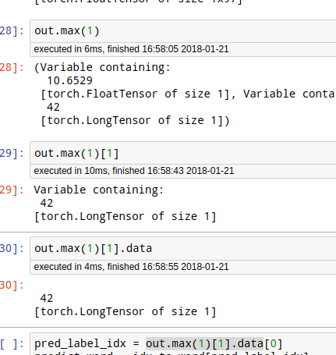

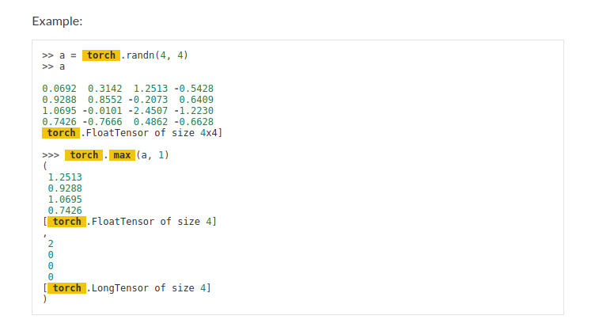

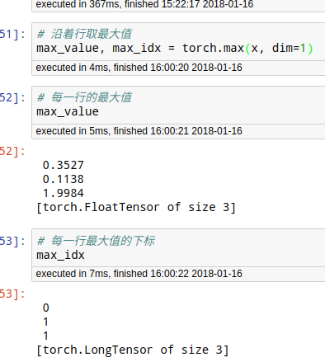

###### torch.sum()

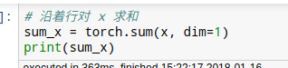

###### torch.squeeze() 只对1维度的有作用

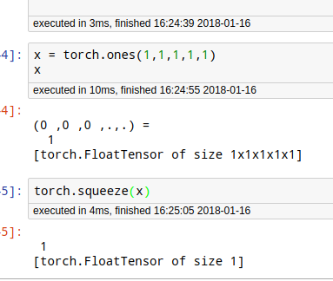

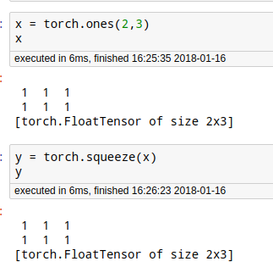

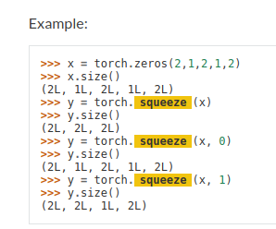

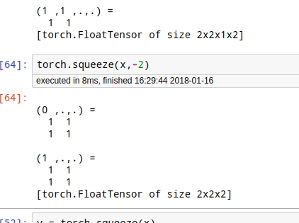

###### torch.unsqueeze

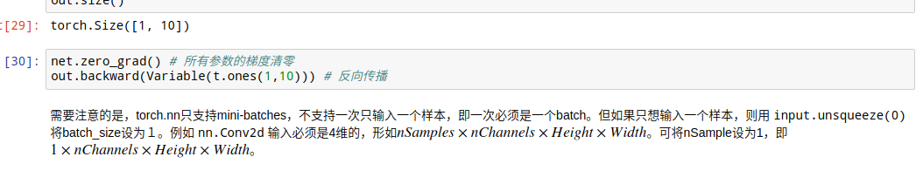

###### torch$tensor.permute

###### torch$tensor.transpose 转换维度：用于RNN

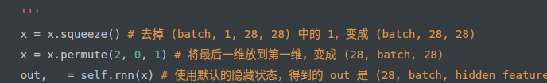

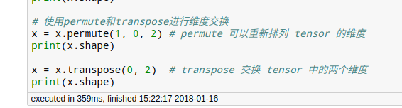

torch$tensor.view() 维度总数不能变

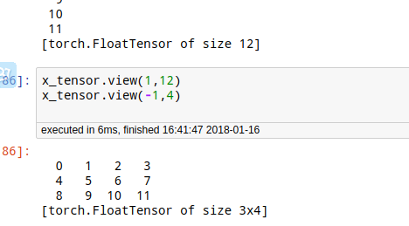

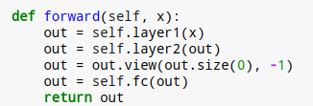

###### torch$tensor.inplace_() 自身操作

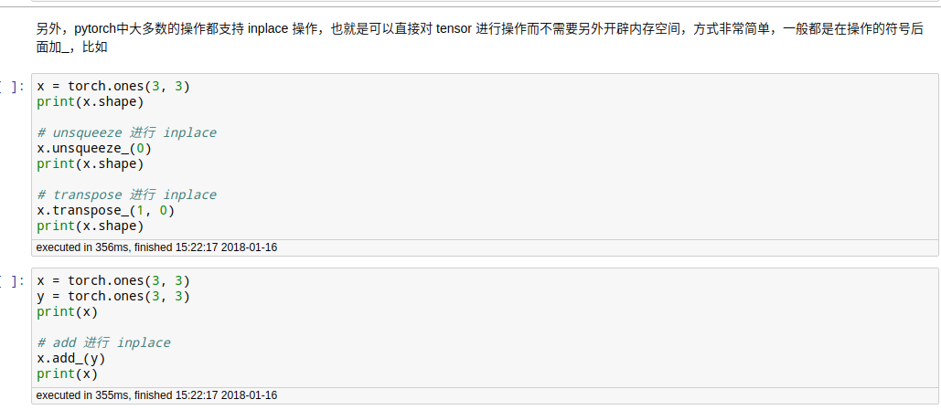

###### torch$tensor[切片]

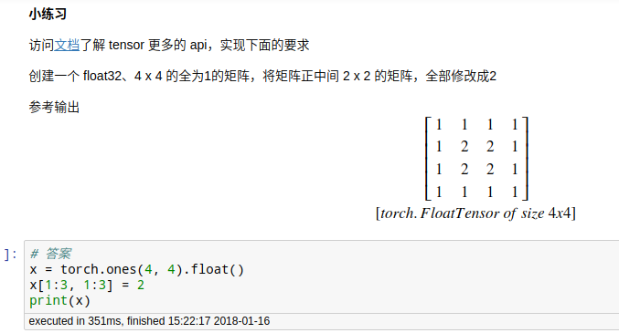

###### torch.mean()　用于计算误差

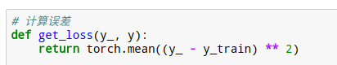

###### 

###### torch$tensor[0]:提取纯数字

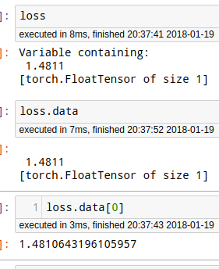

###### torch.arange(15).view(5, 3)

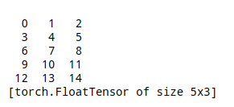

###### torch.cat():总维度不变,单维度增长

dim是几，哪个维度就增长

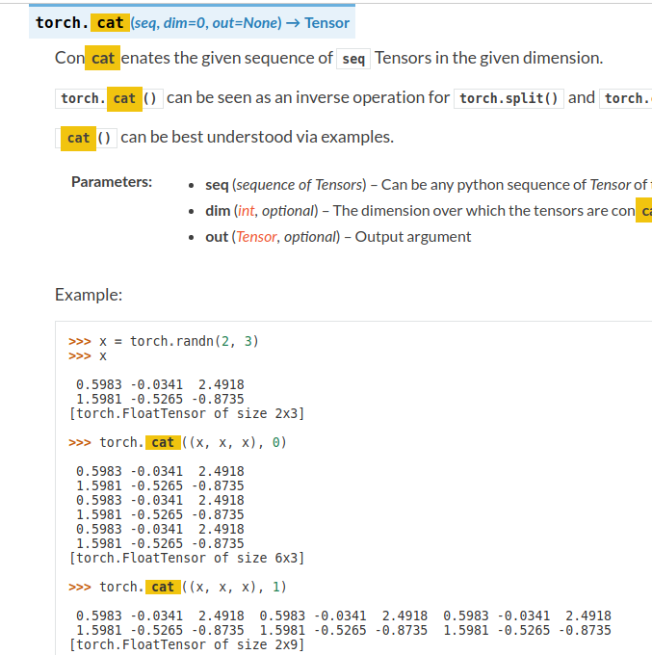

###### torch.stac()k多出一个维度

stack是多出一个维度！！

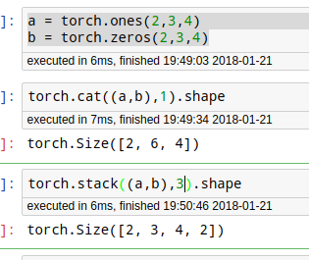to

###### torch.matmul()　广播矩阵乘法

###### torch.bmm() 非广播矩阵乘法

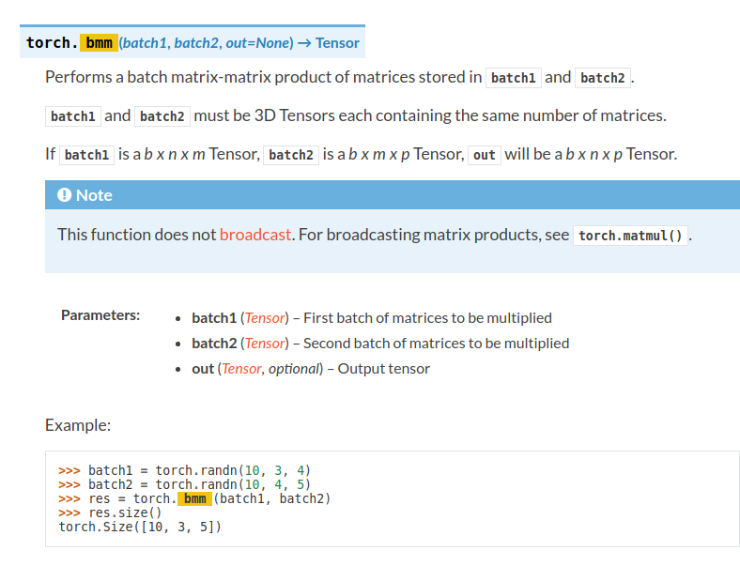

###### 索引与高级索引

<http://localhost:8890/notebooks/code_NOT_CHANGE_NAME/deep_learning_tutorials/pytorch_tutorials/chenyun-pytorch-book-master/chapter3-Tensor%E5%92%8Cautograd/Tensor.ipynb>

###### .t_() 转置

#### 变量

#### torch.Variable(Tensor)

##### Variable 三个属性 data grad grad_fn

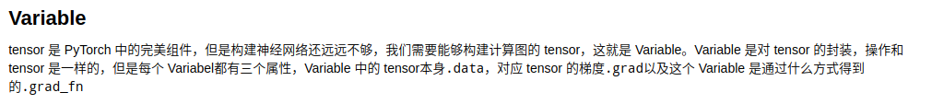

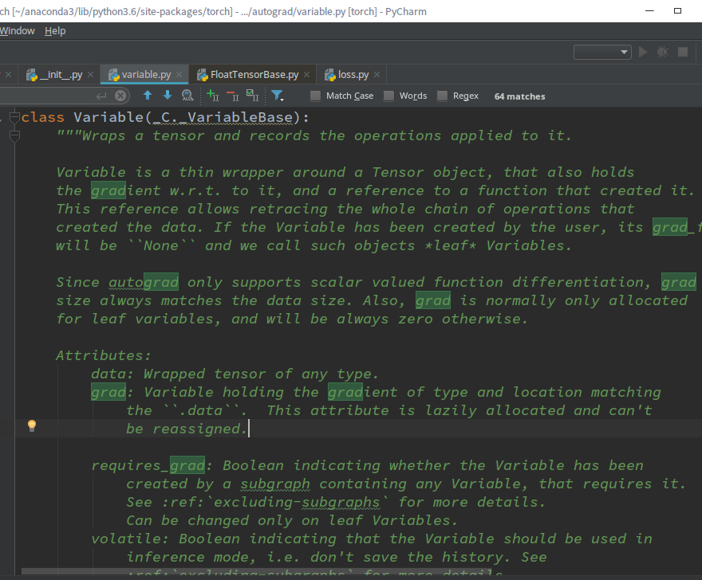

###### 1- variable.data就是tensor

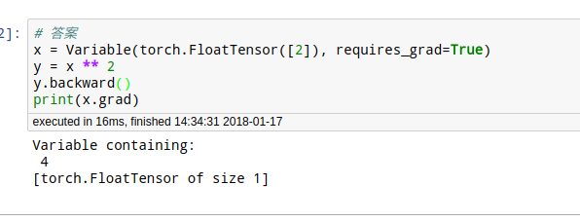

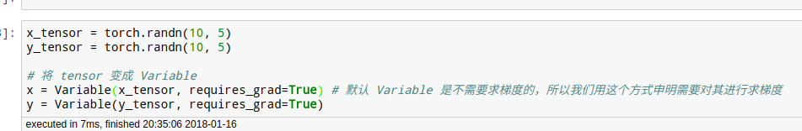

###### 属性

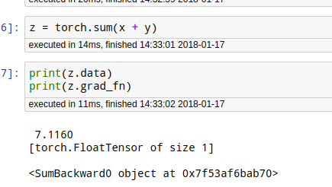

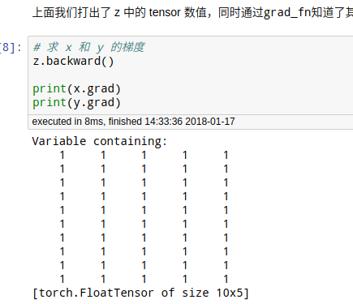

###### 2梯度清零

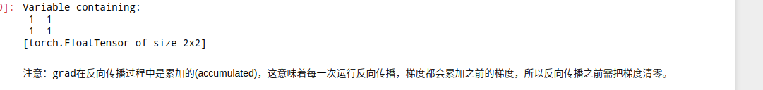

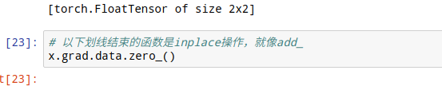

###### 2-谈volitate和require_grad

在True的层面，都是xor运算

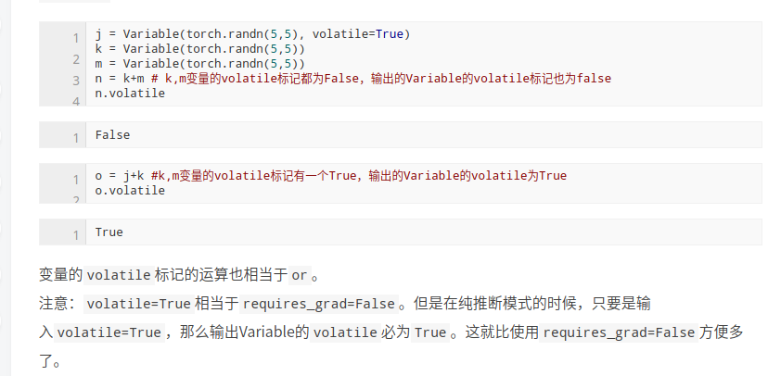

###### 3-例 loss.data[0] 用于提取纯数据！

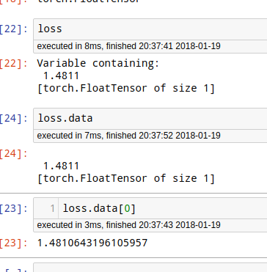

#### 2-1 torch.nn.Parameter()

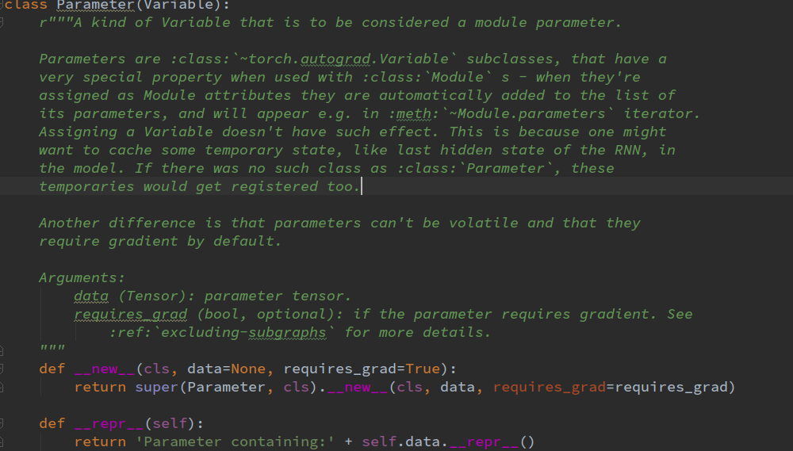

volatile?

requries_grad

###### 实例

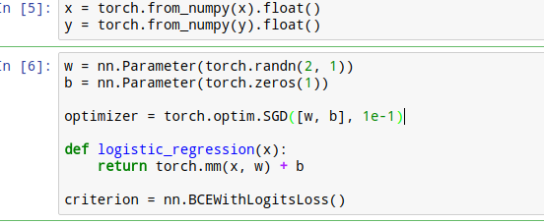

#### 3-自动求导

###### 代码

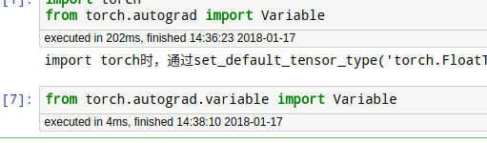

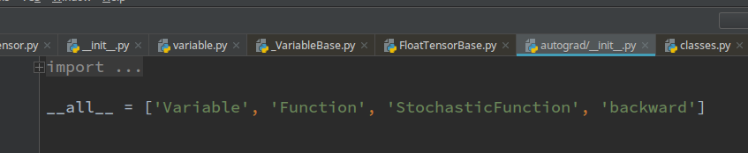

##### 1-标量自动求导

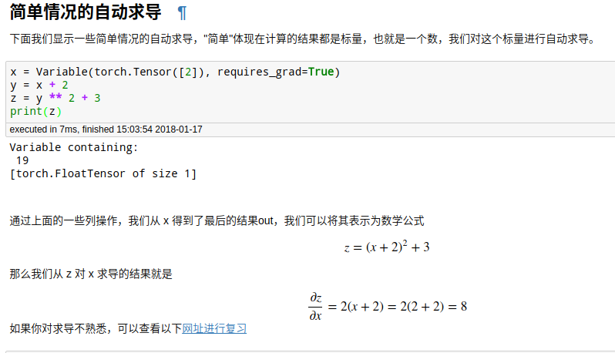

###### 保留计算图（什么情况下可能会多次求导？）

才能多次算梯度

梯度是默认累加的

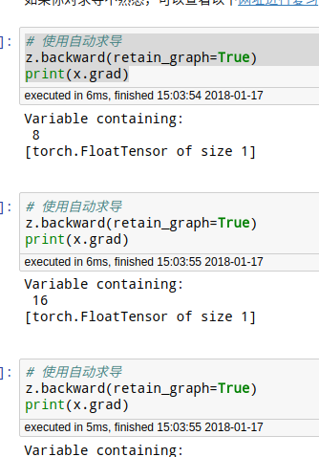

###### 梯度清零

###### 

##### 2-矢量自动求导（现在还没用到，先不研究了）

###### backward参数

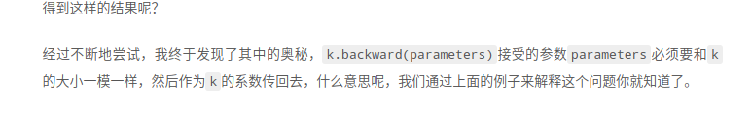

#### 

## 3-动态图 while可改变

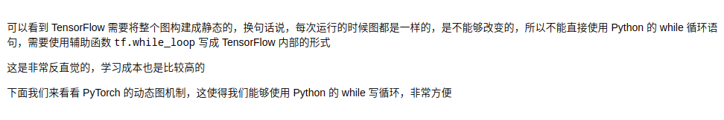

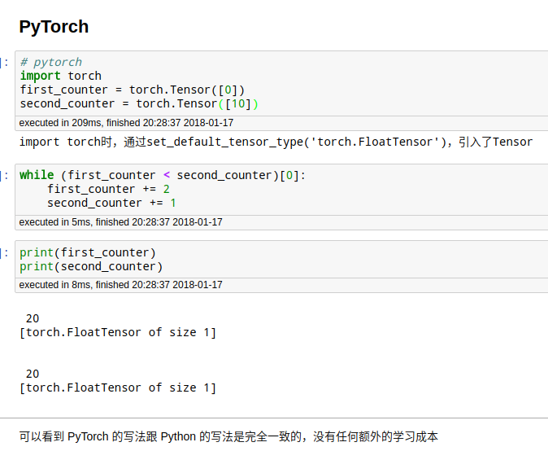

### 二：Pytorch定义模型

##### 1-Sequential

# Sequential  
net = nn.Sequential(  
 nn.Linear(2, 4), # PyTorch 中的线性层，wx + b  
 nn.Tanh(),  
 nn.Linear(4, 1)  
)

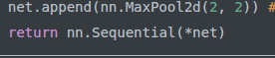

*是为了把列表拆开！！！！！

###### net1.weight

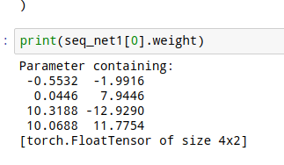

###### net.parameters()

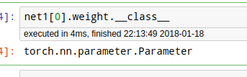

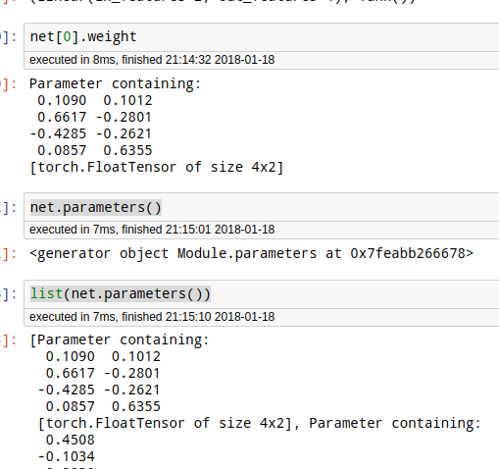

说明是Parameter

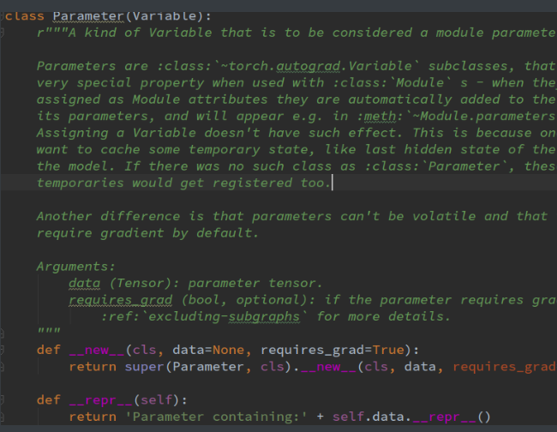

###### 源码-输出网络结构

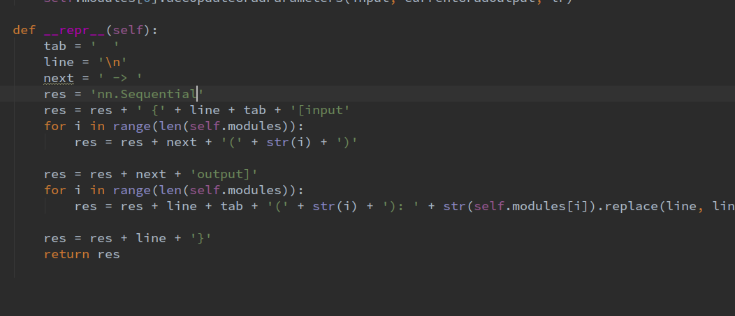

###### 1-2函数包装的Sequenciall

###### 1-2nn.Sequential(*net)

def vgg_block(num_convs, in_channels, out_channels):  
 net = [nn.Conv2d(in_channels, out_channels, kernel_size=3, padding=1), nn.ReLU(True)] # 定义第一层  
   
 for i in range(num_convs-1): # 定义后面的很多层  
 net.append(nn.Conv2d(out_channels, out_channels, kernel_size=3, padding=1))  
 net.append(nn.ReLU(True))  
   
 net.append(nn.MaxPool2d(2, 2)) # 定义池化层  
 return nn.Sequential(*net)

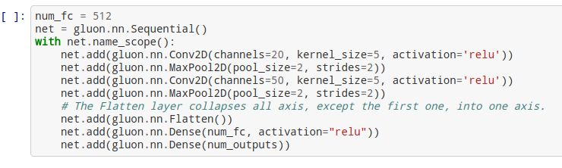

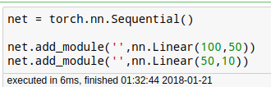

###### 1-3 add_module()

##### fig:2-Module

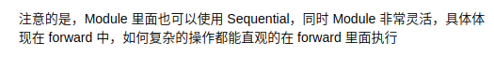

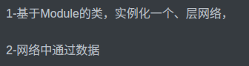

class module_net(nn.Module):  
 def __init__(self, num_input, num_hidden, num_output):  
 super(module_net, self).__init__()  
 self.layer1 = nn.Linear(num_input, num_hidden)  
   
 self.layer2 = nn.Tanh()  
   
 self.layer3 = nn.Linear(num_hidden, num_output)  
   
 def forward(self, x):  
 x = self.layer1(x)  
 x = self.layer2(x)  
 x = self.layer3(x)  
 return x

###### net.children()与net.modules()

modules会搜索到每一个层次，直到最低层

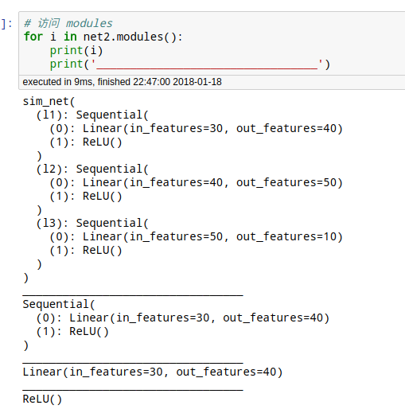

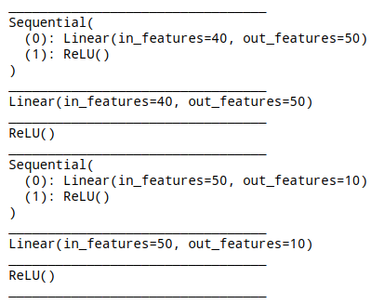

用于初始化

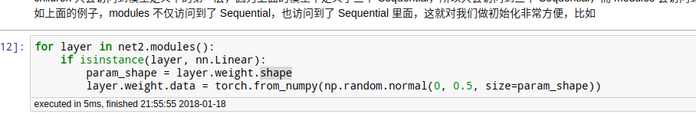

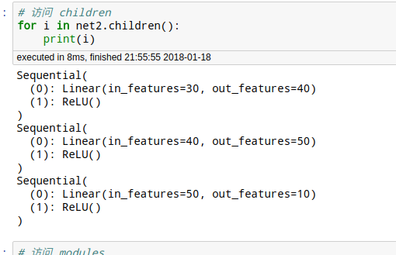

##### 3-打印网络结构

###### 内置打印所有参数 的大小

for name,parameters in net.named_parameters():  
 print(name,':',parameters.size())

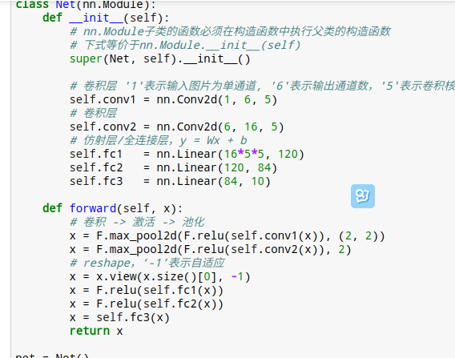

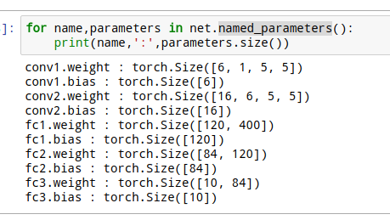

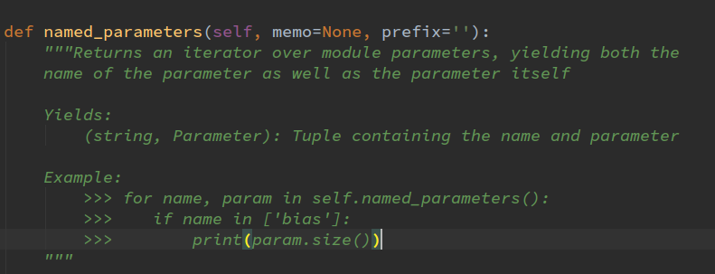

###### 我的打印每个抽象层的大小

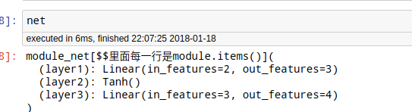

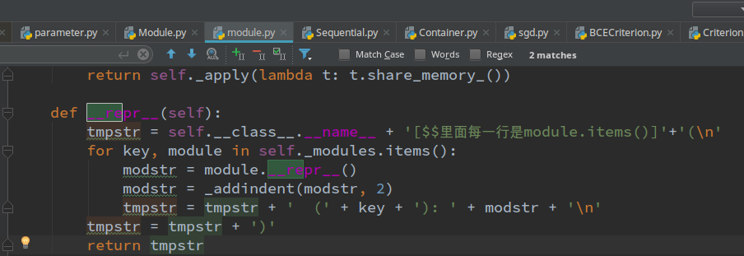

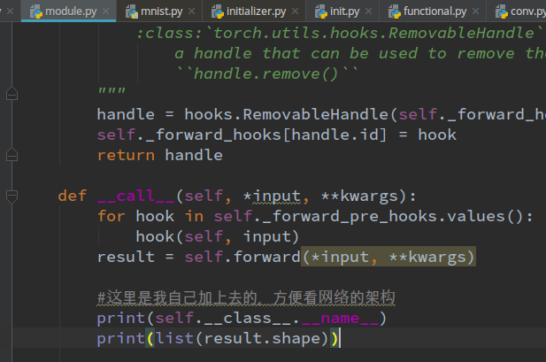

### 三 卷积

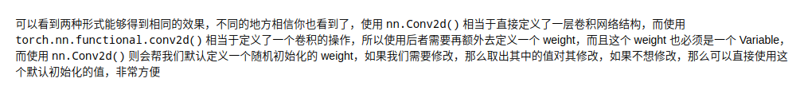

注意！ 完全对应的两套！一般用modules的！

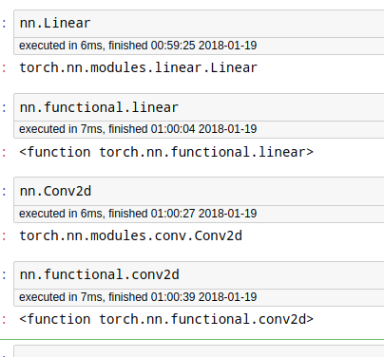

###### 1- F.con2d(input,卷积核)

functional

weight就是卷积核/滤波器

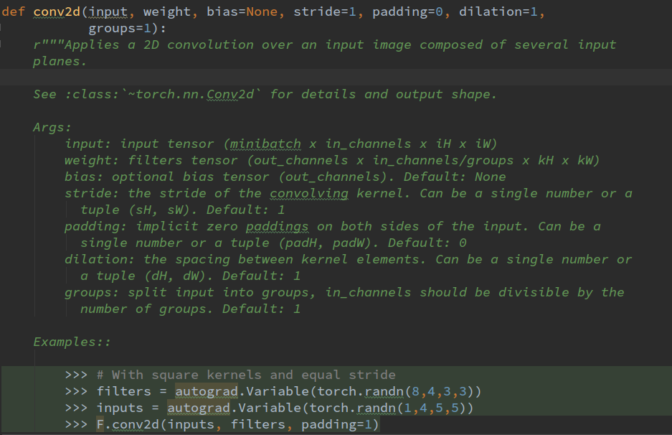

###### 2-con2d实例(input) 推荐 相当于一层网络

1-基于Module的类，实例化一个、层网络，

2-网络中通过数据

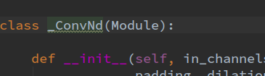

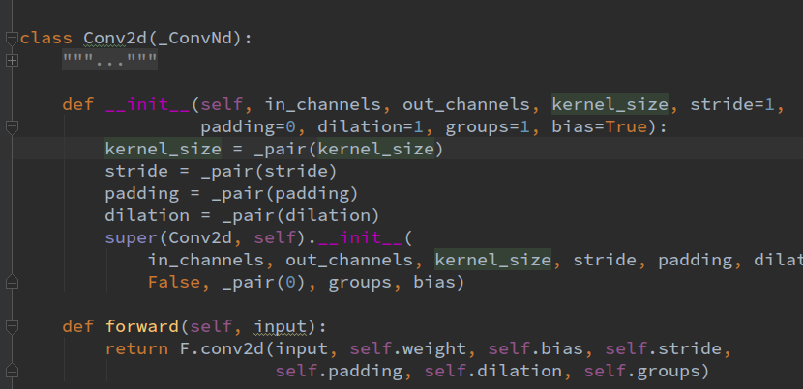

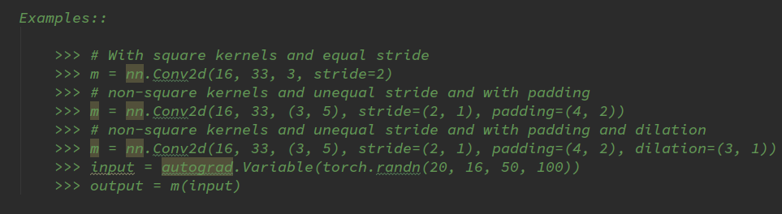

###### 3-轮廓检测

modules版，重装+法初始化

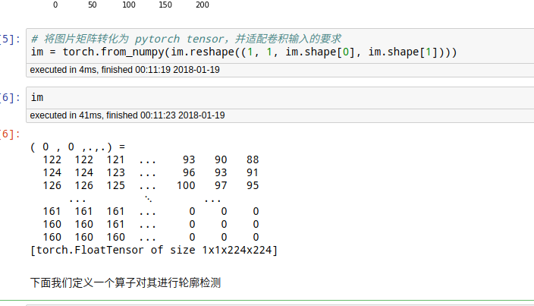

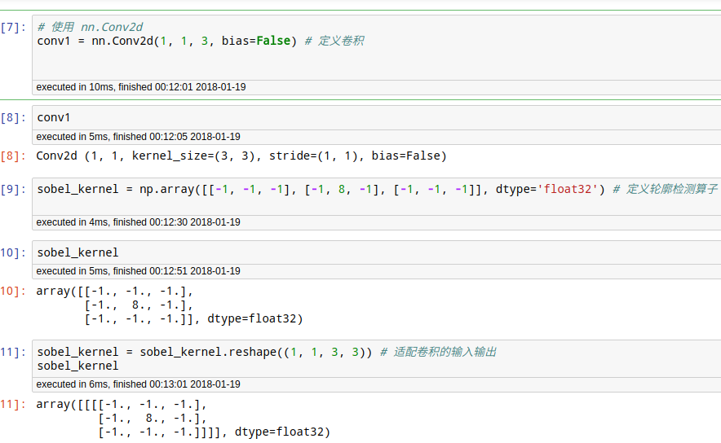

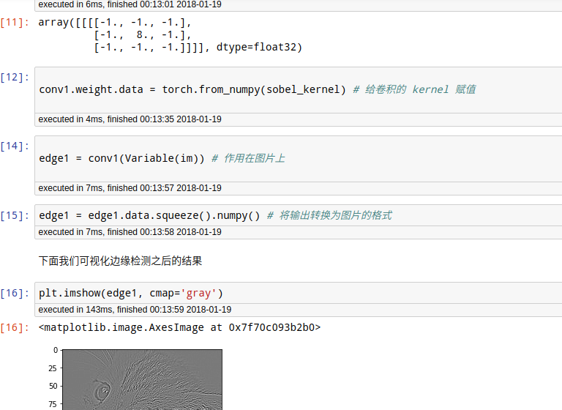

function法

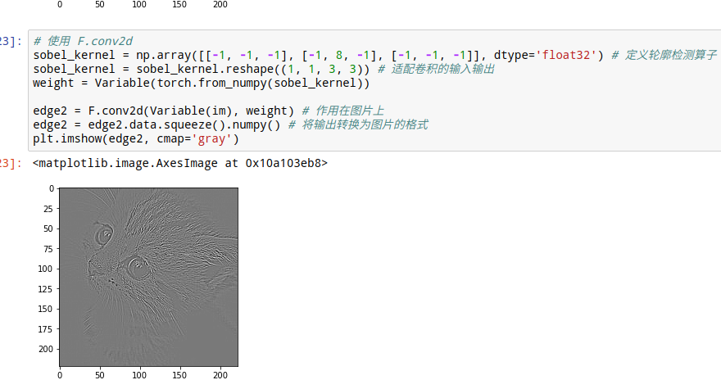

###### 4-最大池化

modules版 推荐

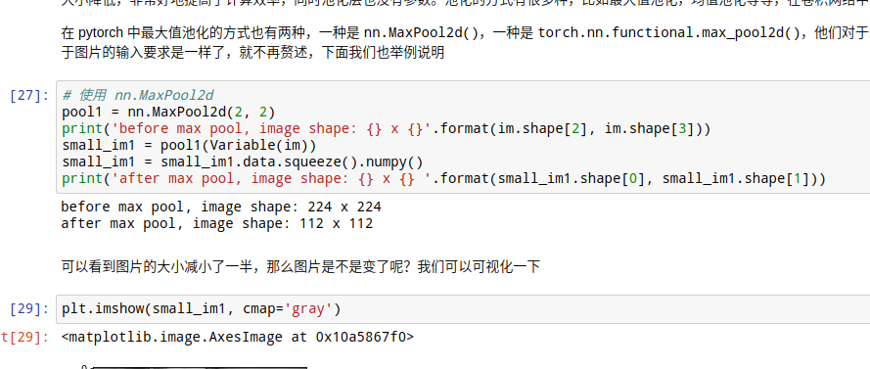

func版

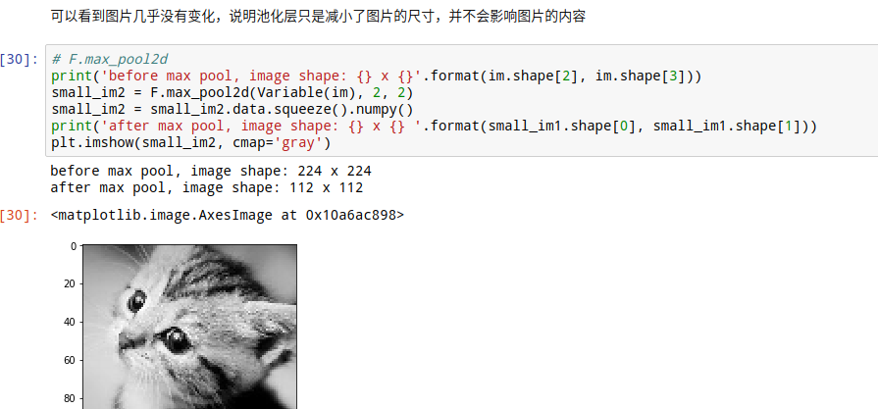

###### 5-BN

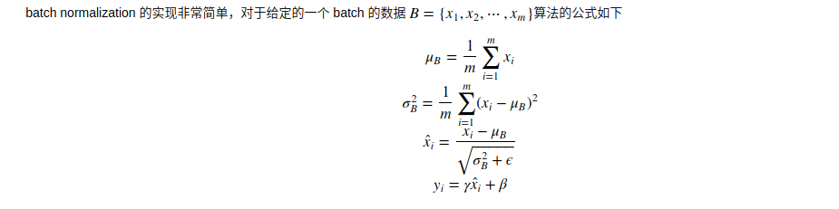

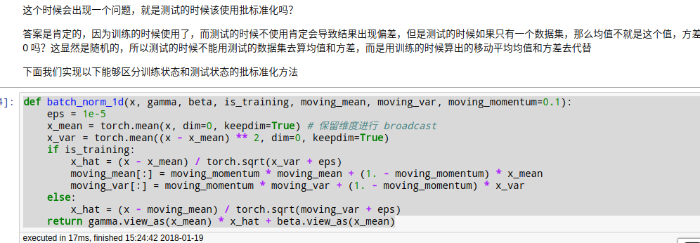

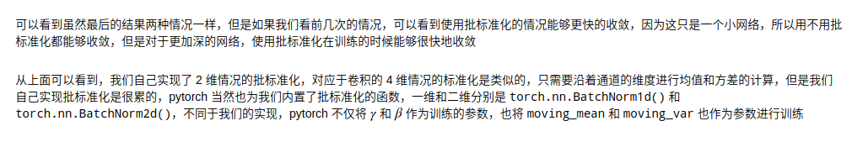

###### 6-学习率衰减 本质修改optmizer.param_groups中的lr

这个只有教学意义。

<http://localhost:8890/notebooks/code-of-learn-deep-learning-with-pytorch-master/chapter4_CNN/lr-decay.ipynb>

optimizer.param_groups

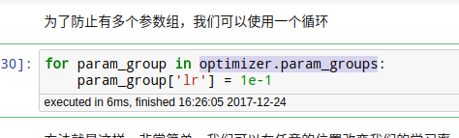

def set_learning_rate(optimizer, lr):  
 for param_group in optimizer.param_groups:  
 param_group['lr'] = lr

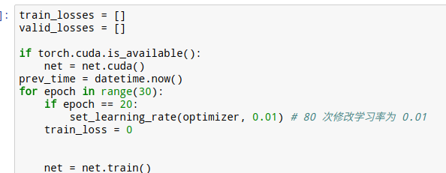

param_group理解





转化为dict的样子

网络的参数







###### 7-Googlenet:和VGG比，没有全连接

#### 实例

###### 图像风格迁移

# 